Condition report and proposed conservation-based intervention for the timber components of the Front Gable Elevation

of

The Old Granary
14, Mill Lane
Godalming
GU7 1EY

For
Revd Ben and Mrs Eleanor Cahill-Nicholls

Prepared by

Roland Locke MSc

7th September 2021

Historic Building Conservation and Repair Ltd, Director: Roland Locke MSc, Correspondence address: Steepwood Bungalow, Adversane Lane, Billingshurst RH14 9EG: Registered company No 8860281 : VAT No 201435168 : Web site: www.hbcandr.com

1. Authority 5
2. Use of this report 5
3. Location 5
4. Setting 6
5. Historical description 6
6. Executive summary 7
7. Aims 8
8. Limitations 8
9. Survey methodology employed 9
10. List of timbers, their condition and proposed remedial action 10
10.1. Terminology and glossary 10
10.2. Identification and location of the area of concern 11
10.3. Designated references 12
10.4. Pattern of decay 13
10.5. General observations 14
10.6. Specific considerations 14
10.7. Posts 15
CP1 Corner Post 16
CP2 Corner Post 18
10.8. Braces 20
B1 20
B2 and S6 21
10.9. Studs 23
S1 23
S2 24
S3, S4, R1 and Panels 4 and 6 25
S5 26
S6 27
10.10. Tiebeam 27
TB1 28
10.11. Rails 28
R1 28
10.12. Panels 29
11. General points concerning repairs 30
12. Conservation strategy 30
12.1. Our general conservation principles 30
12.1.1. General 30
12.1.2. Dismantling 31
12.1.3. Workmanship 31
12.2. Timber 31
12.2.1. Decay and infestation of timber 31
12.2.2. Replacement materials specification 31
12.3. Brick 32
12.3.1. New work 32
12.3.2. Repairs 32
12.3.3. Re-pointing 32
13. Recommendations 33
14. Timescales 33
15. Conclusion 33
16. Estimate 33
17. About the author 34

Table of Figures
Figure 1, Location. Mill Lane, Godalming [Google]. 5
Figure 2, The Old Granary, indicated in RED (Google 2021). 6
Figure 3, Glossary of Timber components. 10
Figure 4, Area of concern. 11
Figure 5, Designated References. [Panels are in RED. 12
Figure 6, Pattern of decay 13
Figure 7, Typical Tiebeam/Wallplate/Post Assembly [Assembled] 15
Figure 8, Typical Tiebeam/Wallplate/Post Assembly [Exploded]. 15
Figure 9, CP1, Top 16
Figure 10, CP1, Bottom. 16
Figure 11, CP1 - Base. 17
Figure 12, CP2 Top. 18
Figure 13, CP2 Base. 18
Figure 14, B1 Base. 20
Figure 15, S6 and B2 Base. 21
Figure 16, S1 Base. 23
Figure 17, S2 at window sill. 24
Figure 18, S2 Top. 24
Figure 19, Intersection of S4, S5 and R1 25
Figure 20, Panel 6 25
Figure 21, S5 Top. 26
Figure 22, Forces acting upon the Tiebeam. 27
Figure 23, Tiebeam above window 1. 28
Figure 24, Tiebeam above window 2. 28
Figure 25, Head of P9 showing gap 29

Authority
Roland Locke carried out an invasive site survey on Friday 13th August 2021 of the front gable elevation of the named property at the request of the owner Revd Ben and Mrs Eleanor Cahill-Nicholls, as a result of emails in connection with reported timber decay and damp found during a pre-sale survey. The report was completed and delivered via email to Mr and Mrs Cahill-Nicholls on 7th September 2021.

Use of this report
This report the property of the addressee and may be used in anyway deemed appropriate to provide information to any prospective purchaser or contractor intending on carrying out the recommended work and if necessary, an application for Listed Building Consent.

Location

Latitude: 51.1858 / 51°11'8"N
Longitude: -0.6179 / 0°37'4"W
OS Eastings: 496693
OS Northings: 143859
OS Grid: SU966438
Mapcode National: GBR FD2.LLP
Mapcode Global: VHFVT.7GQB
Plus Code: 9C3X59PJ+8V

Figure 1, Location. Mill Lane, Godalming [Google].

Figure 2, The Old Granary, indicated in RED (Google 2021).

Setting
The Old Granary is currently to be found in an urban setting close to a tributary of the River Wey and opposite the ‘Old Mill’ https://historicengland.org.uk/listing/the-list/list-entry/1044473. Its roughly square shape is consistent with that of a granary. Further investigation of documentary evidence would I suspect provide a great deal more information about The Old Granary’s history.

Historical description

Entry Name: The Old Granary
Listing Date: 23 February 1970
Last Amended: 1 February 1991
Grade: II
Source: Historic England
Source ID: 1352713
English Heritage Legacy ID: 291451
Location: Godalming, Waverley, Surrey, GU7
County: Surrey
Civil Parish: Godalming
Built-Up Area: Godalming
Traditional County: Surrey
Lieutenancy Area (Ceremonial County): Surrey
Church of England Parish: Godalming
Church of England Diocese: Guildford

Listed buildings description
GODALMING MILL LANE
SU 9643 NE
(north side)
12/171
Nos 14 (The Old Granary)
23.2.70
16 and 18 (formerly
lined as Nos 14 and 16)
GV
II

One or two houses, now 3. Probably early C17, with later C17 wing and
subsequent alterations, especially C20. Timber-framed with painted brick
infill; painted brick and rubblestone; some tile-hanging; No 16 of Bargate
rubblestone with red-brick dressings incorporating some timber-framing. Plain
tile roofs. One storey with attic. No 16 is of 2 bays with No 14, in line on
right, gable-end on of 1 x 2 bays; wing to rear left (No 18). C20 small-pane,
wood-framed casement windows throughout. No 16 has glazed door with side-light,
2-light window and segmental brick-arched passageway to ground floor; two
3-light, hipped gableted dormers with stack between, forward of ridge, and one
at right end. No 14 has rubblestone ground floor with two 2-light windows, and
timber-framed 1st floor with tension braces and two cross-windows with tile
pentices rising into tile-hung gable; right return similarly of rubblestone to
ground floor, with C20 door on right, and of square-panelled timber frame above,
with tension brace on left. Rear: No 16 has vestigial timber-frame comprising
wall-post on left and mid-rail with mortices in soffit from former wall.
Projecting on right is No 18 which has square-panelled timber framing to 1st
floor, part-glazed door and window below 3-light hipped dormer, and C20
additions to rear. Interior: No 14 and 16 not inspected; No 18 has various
exposed timbers.

Listing NGR: SU9669343859

Executive summary
The scope of this investigation and report covers only the condition of the front gable elevation of this building.
I suspect that sadly much of the historic timber frame has been lost to decay as the ground floor appears to have been rebuilt in stone and brick. This process of erosion continues in the first floor, as many of the historic timbers show signs of decay.
Decay is present in many vertical and inclined principal structural timbers at their base and at the main connection with the tie-beam and wall-plates from the side walls. Decay is also of concern in the secondary timbers in the centre of the elevation as their reduced volume is beginning to allow the brick panel infill to drop and become loose at the head of the panels.

However, it is important to see this in context. The building is over 400 years old. Many changes have occurred in its lifetime, not least, it’s change of function from granary to dwelling. Put in those terms, most of the defects noted are relatively small and unlikely to present any major problem for many years. Like any building, a programme of routine maintenance and repair is important and many of these issues could be included in such a programme and completed over a period of years rather than months.

Aims
The aim of this report is to provide;

- Prepare a detailed written conservation based remedial scheme and specification in preparation for Local Authority Listed Building approval.
- Advise on the effects of the paint/coatings to the same elevation.
- A detailed written report describing the issues, extent of decay and suggested remedial scheme and specification.
- An estimate for any work recommended.

Limitations
Although we have huge experience in working on historic buildings and have been trained to a master’s degree level of qualification, we are not surveyors and are not RICS qualified. We offer the information contained in this report as “best advice” only. No liability will be accepted.
This report is limited to the accessible timbers and brick panel infill on the front gable elevation only. (Indicated in Red in Figure 4) and does not deal with any other material connected with the building.
The condition of any concealed timbers may be deduced from the general condition of other timbers and the structure in general.
Our experience and training enable us to make a judgement on the likelihood and extent of decay, particularly where hidden by patches of timber and cementitious mortar. Only invasive investigation or their removal can reveal the full extent. These areas may be concealing more decay than described. Similarly, only demolition or exposure work can enable the revelation of concealed timbers and their condition to be fully determined with any certainty, and this destroys the historic fabric intended of conservation. Specialist investigative techniques are therefore available as aids to the survey. No such technique can be 100% reliable, but their use allows deductions to be made about the most probable condition of the fabric at the time of examination in assessing the extent of decay.
Structures and timbers were not examined in detail except where described in this report, and no liability can be accepted for defects that may exist in other parts of the building. We have not inspected timbers or other parts of the structure that are covered, unexposed or inaccessible and we are therefore unable to report that any such part of the property is free from defect or in the event that such part of the property is not free from defect it will not contaminate and/or affect any other part of the property. No formal investigation of moisture distribution was made.
Absolute identification of timber species is only really possible by end grain analysis, this analysis should be carried at the remedial action stage and the appropriate timbers procured.

Survey methodology employed
An invasive survey was carried out on 13th August 2021 where we carried out the following:
- An inspection of the timbers in the whole of this elevation, particular attention was given where materials have been used to fill areas of decay.
- We exposed the joints and investigated the condition of the timbers in the first-floor timber-frame where they abut with the Bargate stone on the ground floor wall.
- We attempted to determine the likely cause of any water ingress.
- And finally, we made good with non-hydraulic lime mortar areas which were exposed during the investigation.
The assessment of the timbers included in this report was primarily visual; however, a four-inch-long metal probe was employed to assess the depth of decay. As there exists a internal covering wall, timbers were only tested from outside of the building and the position and depth of identified decay plotted on a scale drawing to compile a thorough depiction of the pattern of decay.
A linen tester was employed to assess the size and shape of insect flight holes for determination of species and identification of fungal infestation was by visual examination.

List of timbers, their condition and proposed remedial action

Terminology and glossary

The drawing below illustrates the timber frame concerned. Each of the timber components has been identified by its usual terminology used within the industry for discussion within this document.

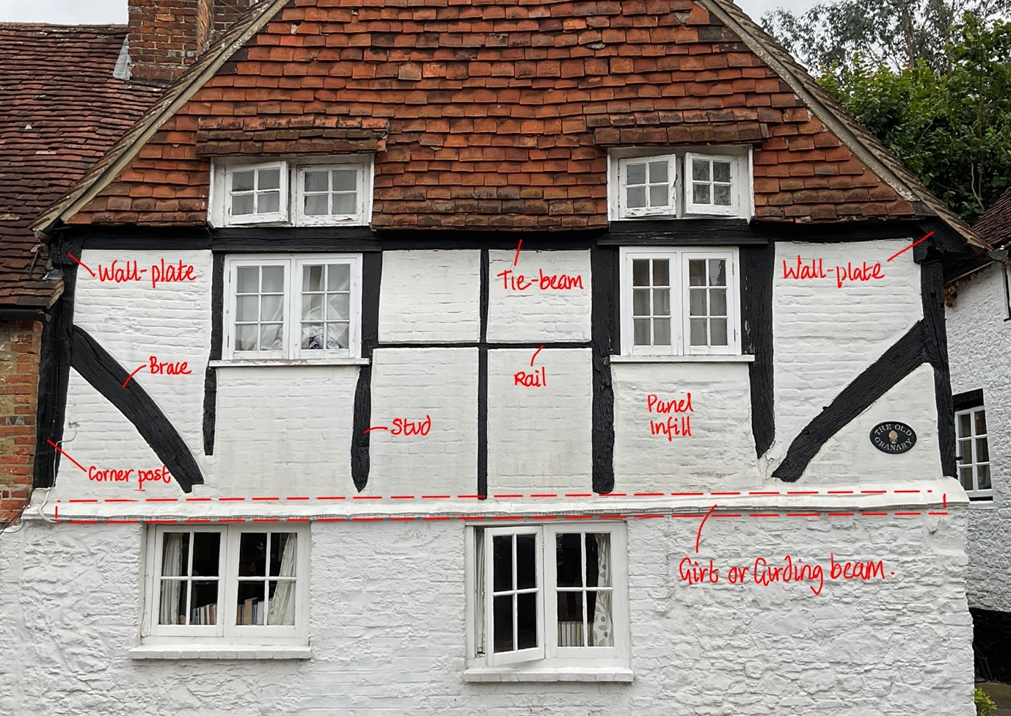
Figure 3, Glossary of Timber components.
Glossary of timber Components (Author 2020).

The drawing above gives the names of the main components and their location within the elevation, frame and building.

Brace
A subsidiary timber; curved or straight, normally running between vertical and horizontal members in a frame. May be further distinguished by its direction in relation to a post, e.g. Downward brace, Upward brace.

Corner Post
A full height principal structural timber forming a corner to the building.

Girt
Sometimes known as a transverse or girding beam
A horizontal timber which spans the width of the building at the level of a floor.

Story Post
A vertical timber usually of substantial size and connecting the sill beam with a wall plate.

Rail
A horizontal timber set within the wall frame and between vertical timbers.

Stud
A subsidiary vertical timber set in a wall frame or partition.

Tie Beam
The main transverse timber connecting wall plates intended to resist the spread of the wall plates.

Wall Plate
A horizontal longitudinal timber set at the top of a wall to which the rafters are connected above and studs and posts below.

Identification and location of the area of concern
The area of concern is the 2 story ‘front gable’ located at the roadside and which forms the Southwest elevation of the building. As below indicated in red.

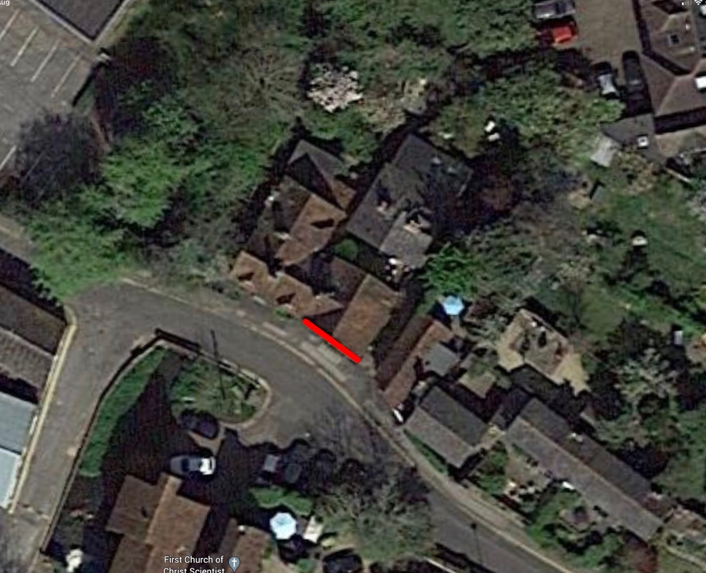
Figure 4, Area of concern.

Designated references
Because within any frame there are usually more than one of any type of timber component, we have labelled each timber, panel and window with a reference and a corresponding reference appears as a heading for the description, condition report and any proposed remedial action for that timber in the text below.

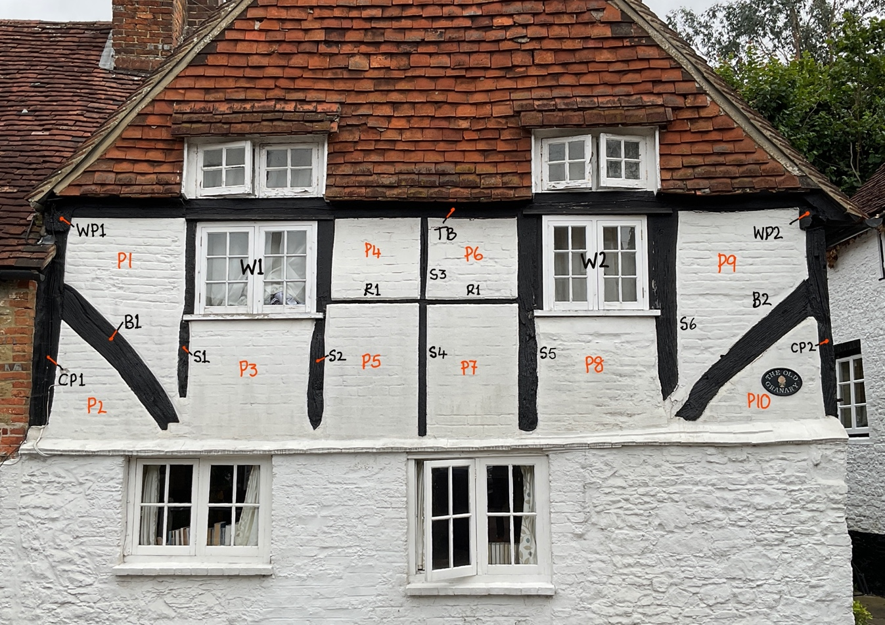
Figure 5, Designated References. [Panels are in RED.

Pattern of decay

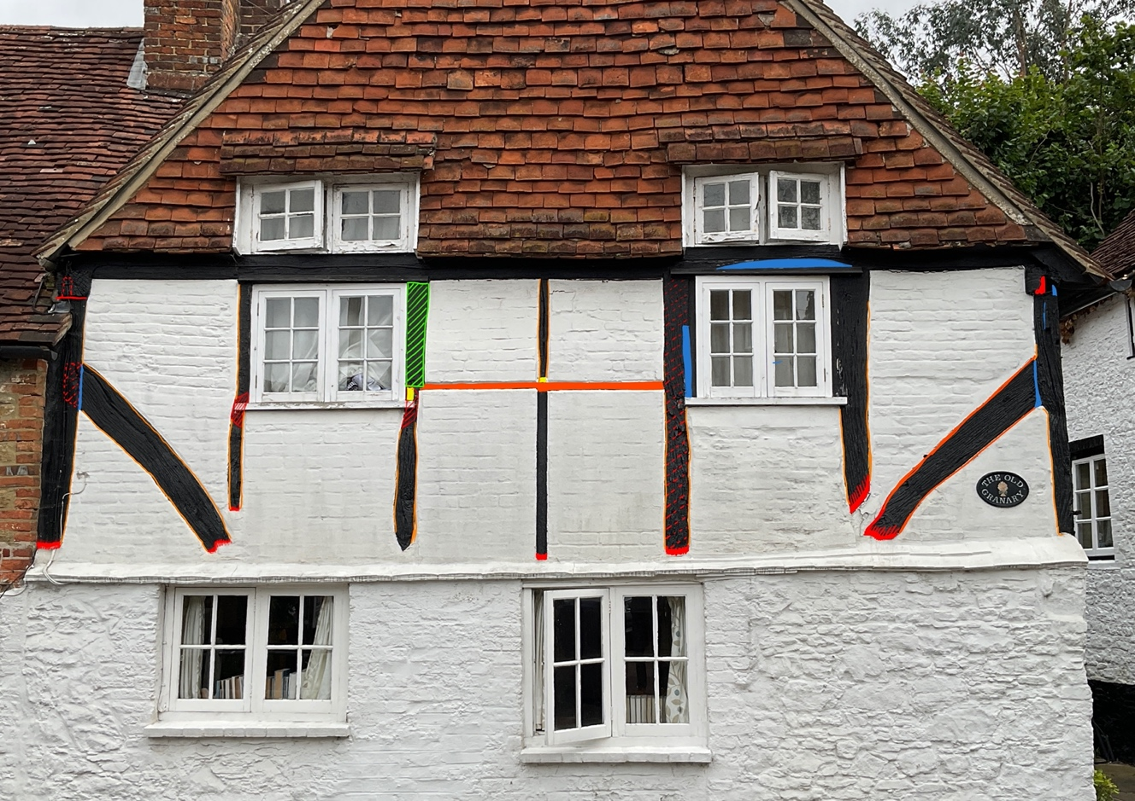
Figure 6, Pattern of decay

Legend:
Areas of decay are highlighted;

- Yellow, areas are timber patches.
- Orange, soft timber areas.
- Red, decayed timber areas.
- Blue, bitumen or other filler.
- Green, is cover boarded.

Images illustrating the condition of that particular timber appear within each description.

General observations
All of the timbers are covered in heavy black paint or bitumen which may be concealing areas of decay or historic repairs and additionally preventing the evaporation of moisture which leads to agents of decay. Some of the joints between timbers have been filled with either a bitumen, mastic, or cement-based material and although in most instances these appear solid, their presence will eventually lead to decay in the timber behind and around its margins.
Panels are filled with brick that has been painted with a masonry paint which in a historic building with no damp proof course and soft bricks will trap moisture, resulting in increased moisture content. When the moisture content reaches 17.5% agents of decay can inhabit materials and when it reaches 21% wood boring beetles and fungi can thrive.

During our visit we noticed that the inside of the building appears to have a wall lining. The purpose of which is lost with those who owned the property at the time and builders that carried out the work. But usually, this sort of work is either aesthetic; [to cover unsightly, or to create flat and smooth surfaces]. But sometimes the purpose of this work is to cover unresolved damp issues. Either way the application of impervious materials, paints and mastic prevent the natural evaporation of moisture which leads to issues around damp.

Specific considerations
Many of the decayed areas in this elevation are small but could have potential serious consequences if not addressed. When considering the appropriate action for repairs in these areas we have considered our conservation policy [see section 12] and suggest that:
- A small area of mortar is removed around the decayed part of the timber to enable access to the decay.
- Then that all the decayed timber is cut away using either chisels or a saw back to sound timber.
- Non hydraulic lime mortar is used to replace the decayed timber which should not be painted unless with lime wash or clay paint.

There is a risk that with repeated action like we have suggested above, that over the course of many years, eventually there will be little left of the original timber in question. However, at present, the decayed area is small and to affect a timber repair would require substantially more of the original timber being removed. It is hoped that with the minimal intervention described and the advice followed, that this erosion of the historic fabric will be slow or non-existent and retain the maximum of historic fabric. But at some time, it will be necessary to replace the timbers and a good visual record will be essential in providing the information required to re-construct the frame to restore its appearance.

Posts
Before discussing our concerns for the corner posts, it is important to understand the unique arrangement of timbers found at the head of the posts in historic timber framed buildings. This connection is probably the most important structural joint within the entire timber frame, as the stability of the building relies upon it.

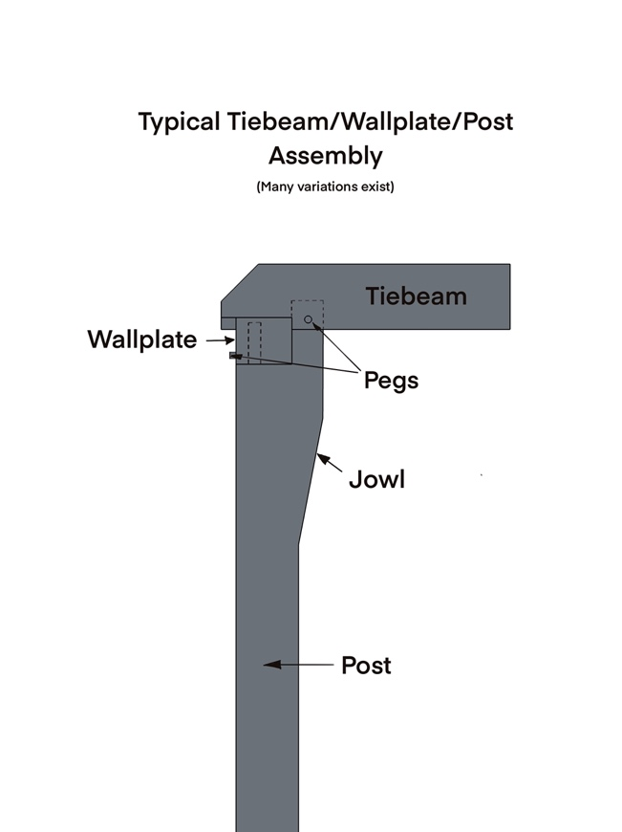  Figure 7, Typical Tiebeam/Wallplate/Post Assembly [Assembled] | 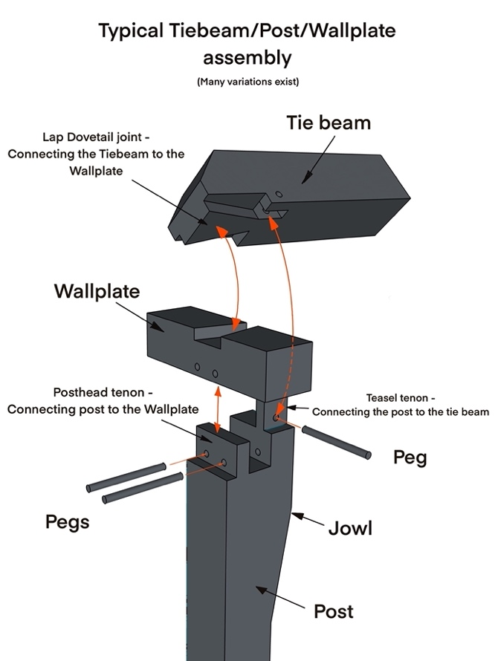  Figure 8, Typical Tiebeam/Wallplate/Post Assembly [Exploded].

The image above describes a typical connection of the three major structural timbers: Corner Post, Wall Plate and Tie-Beam.
In this instance [at the Old Granary] there is no swelling at the head of the post called the jowl, The posts are straight and the same width as the wallplate.

CP1 Corner Post
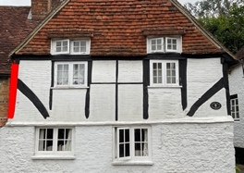

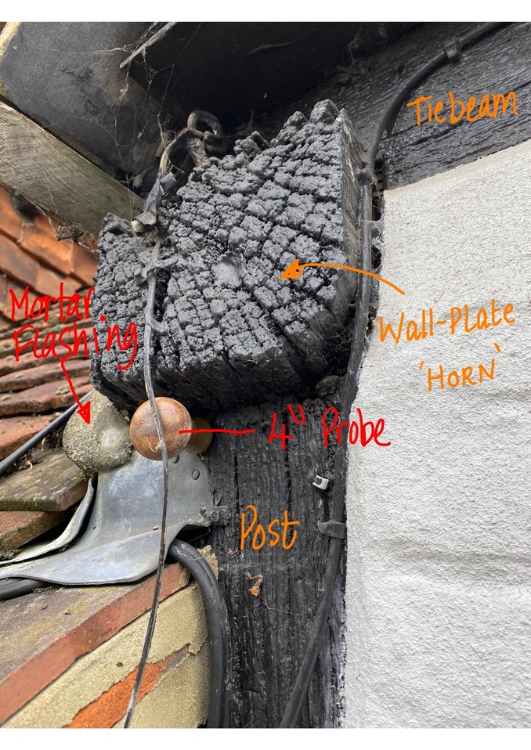  Figure 9, CP1, Top | 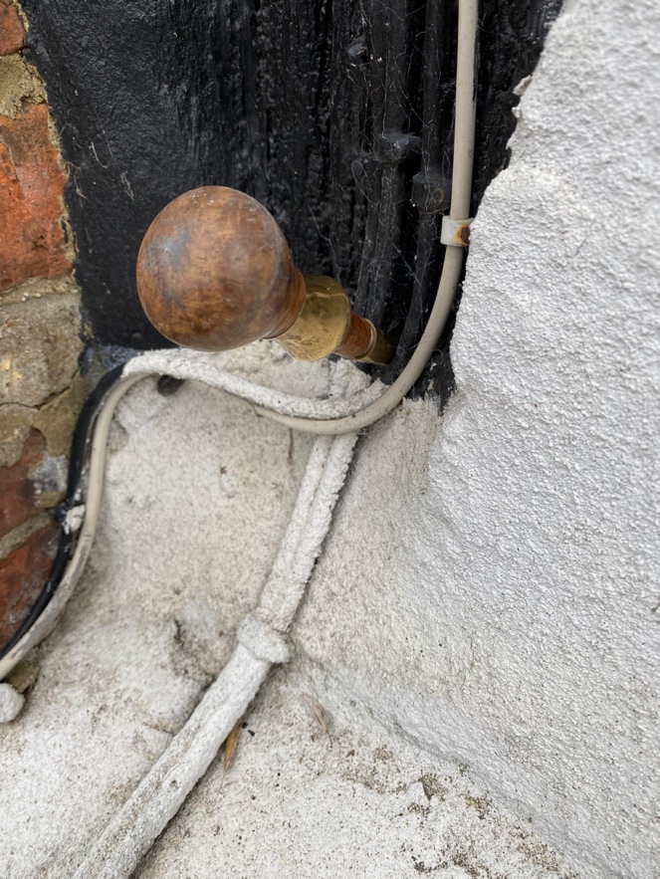  Figure 10, CP1, Bottom.

Corner Post 1. Located at the far left of the front elevation.

Top
Observations
We can see that the ’horn’ [protruding end of timber] of the wall-plate is decayed on its upper surface, which has allowed water to penetrate through to the [mortise in the wallplate] and [tenon of this corner post]. In addition, the mortar flashing on the neighbouring roof has come loose allowing water to run down the roof and wet the outer surface of the wall plate and post. We can see that my 4” [100mm] steel probe has penetrated completely, exhibiting a complete loss of the tenon.

The post head tenon here at the Old Granary has suffered from continuous wetting, resulting in raised moisture content of the timber which has in turn led to agents of decay and total loss of the tenon.

In the normal situation where this post forms the top corner of the building, there would be a risk of the wall plate moving outward under the loadings from the roof causing ‘spreading of the rafter feet’ and distortion of the roof and wall frames. However, in this instance the wall plate is prevented from moving by the presence of the neighbouring roof.

Suggested remedial action.
- The neighbours mortar flashing should be re-done, possibly in lead.
- A lead cover could be made to go over the upper surface of the wall plate rising up to the soffit of the tile under-cloak.

Base
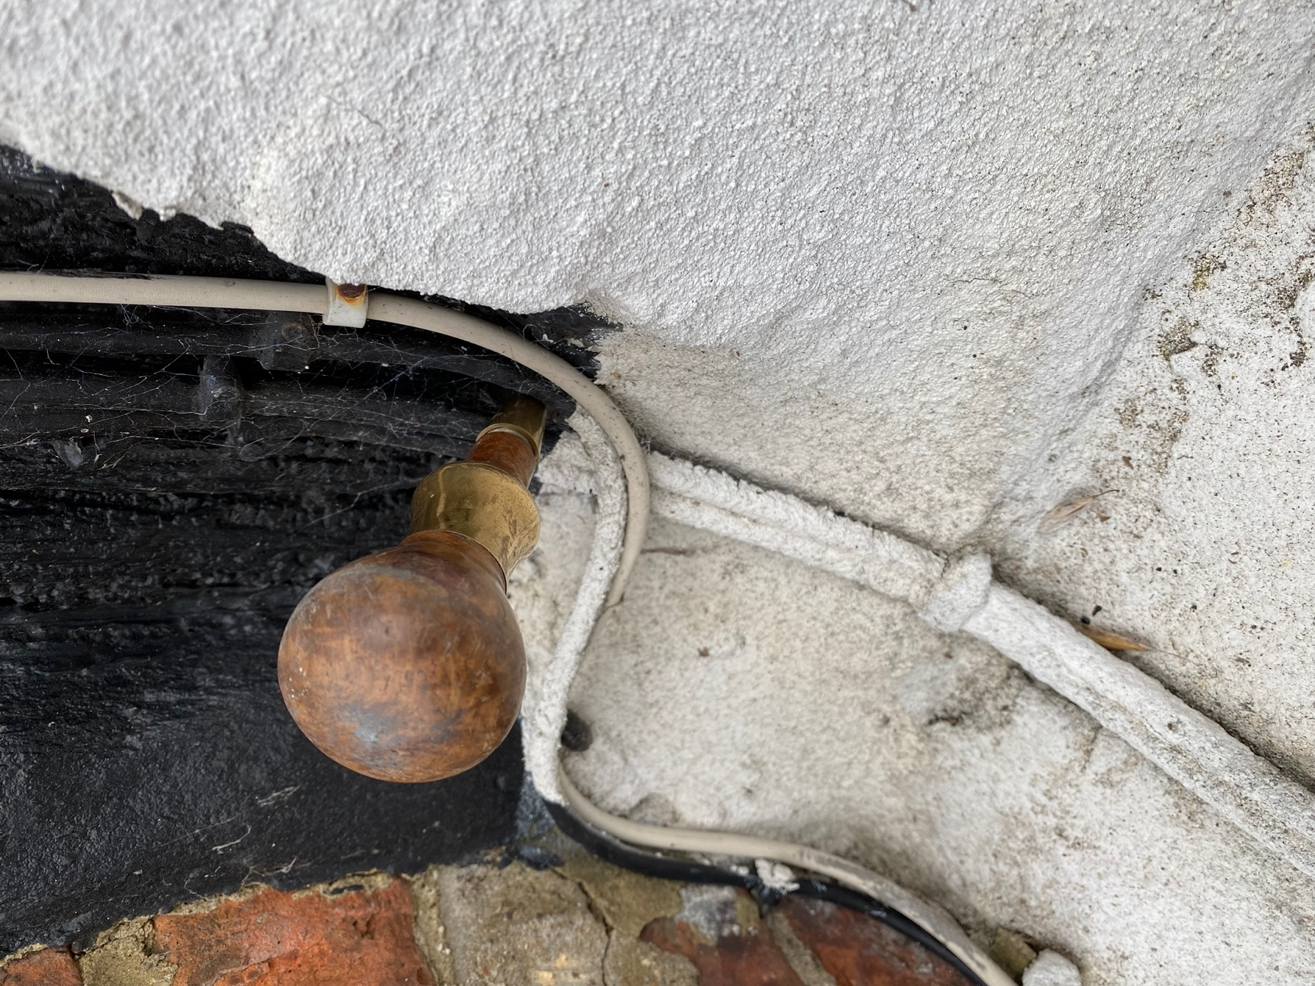
Figure 11, CP1 - Base.

Observations
We can see that the probe has penetrated full length showing that the base of the post where it meets masonry has decayed full thickness.
As the corner post is a primary structural component it is taking loads from the roof, walls and floors. Although some load paths may now include the panel infill it is important that the structural frames integrity is restored.

Suggested remedial action
(See 10.6)

Estimate
This work should be in the region of £600 + VAT

CP2 Corner Post
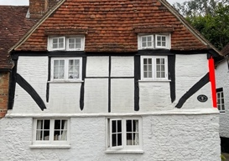

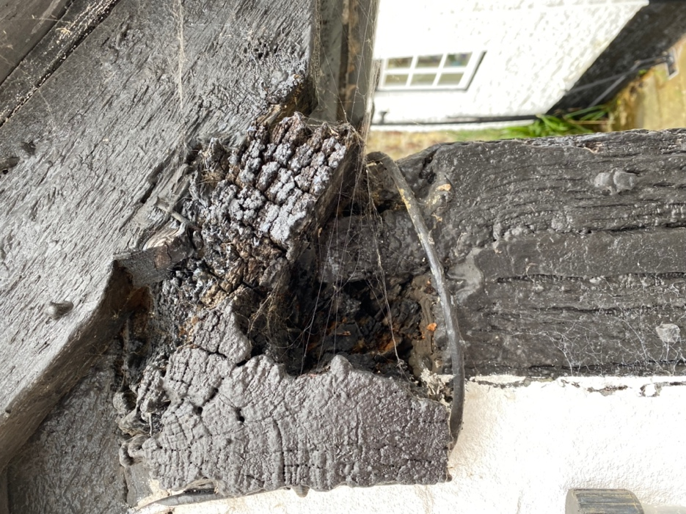  Figure 12, CP2 Top. | 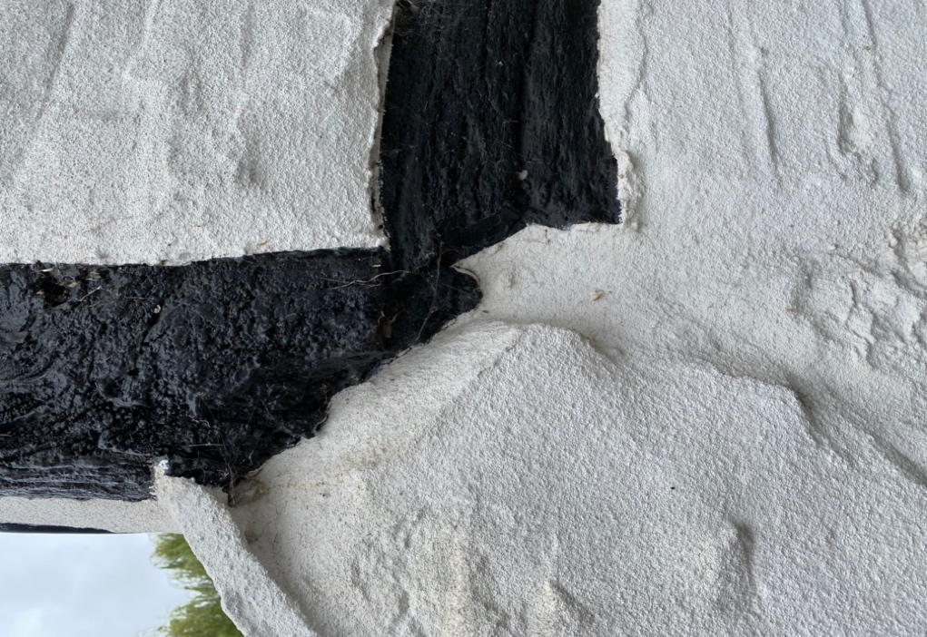  Figure 13, CP2 Base.

Observations
In this configuration the components are mirrored from those of CP1. But in this instance the wall-plate has decayed to the point where there is little mortise to house the tenon. However, unlike CP1 there is no neighbouring building offering restraint to outward thrust at the eaves.

Suggested remedial action
A metal bracket should be designed that connects all three structural members. An internal one I think is most likely be the simplest, although this will involve making a temporary access through the internal lining. Which would only have minimal disruption to the internal space and do not require any changes in occupation.
Additionally, but not essential, as, with the joint re-enforced with the bracket, it would be more for aesthetic purpose. The decay of the wall plate could be removed from the top of the post and the wall plate repaired.

Estimate
About £2500 + VAT

Braces

B1
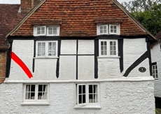

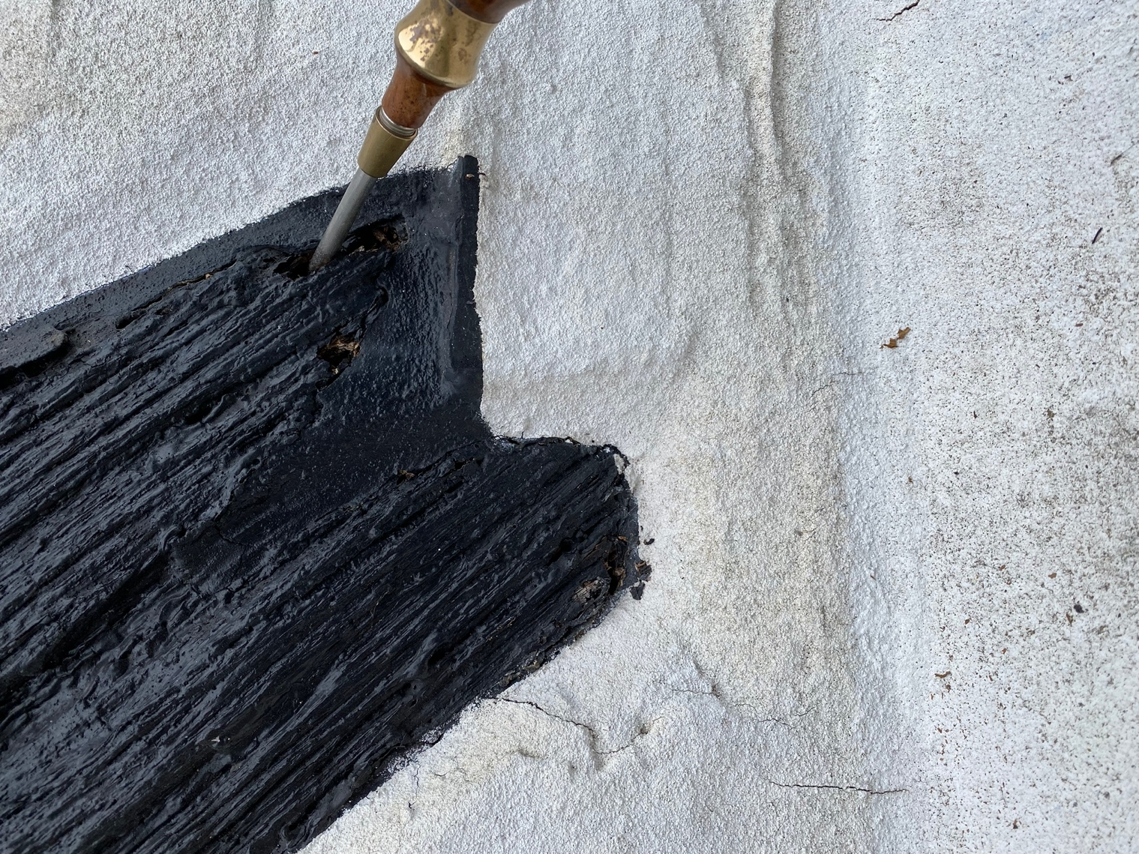
Figure 14, B1 Base.

Observations
We can see that the probe has penetrated approx. half its length, But braces are usually between 2 and 3 inches, showing that the base of the post where it meets masonry has decayed.
A brace is usually a primary structural component and prevents distortion of the frame through ‘racking’, but in this instance where there is a neighbouring building and brick infill restraining movement, unless removed there’s little chance of that.

Suggested remedial action
(See 10.6)

Estimate
£150 + VAT

B2 and S6
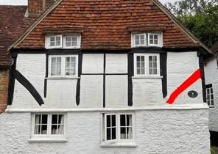 | 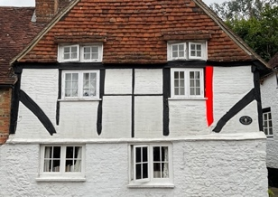

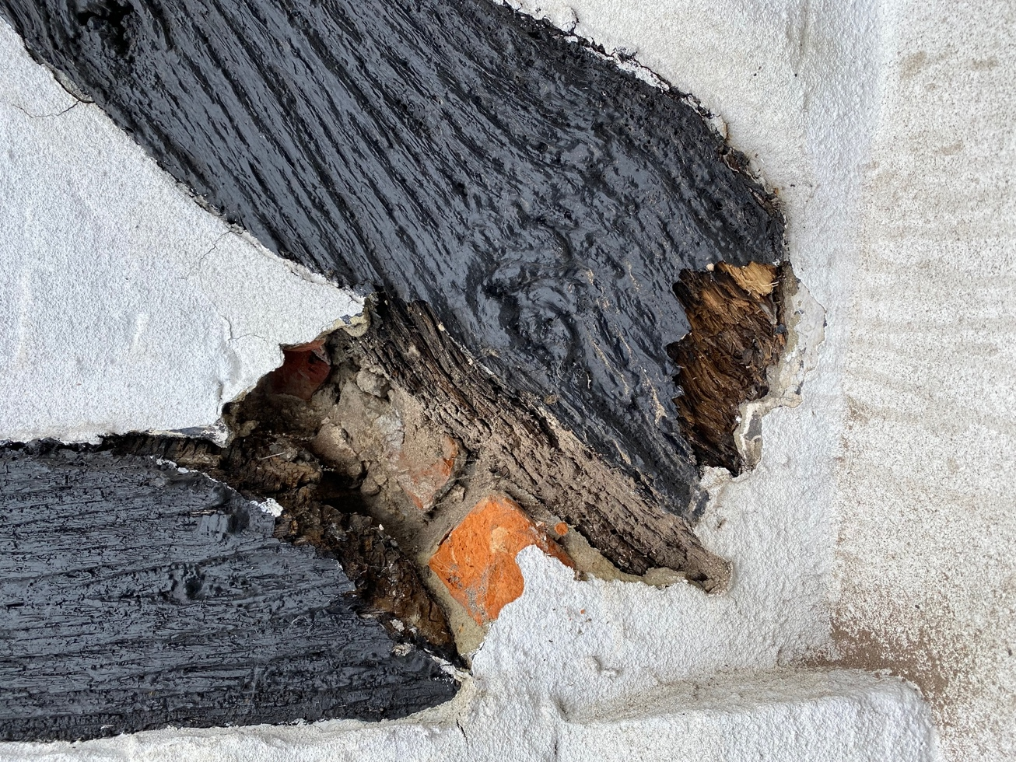
Figure 15, S6 and B2 Base.
Observations
We can see that base of the brace B2 where it meets the stud S6 and masonry that the timber has decayed and been filled with rubble.
A brace is usually a primary structural component and prevents distortion of the frame through ‘racking’, but in this instance where there is a neighbouring building and brick infill restraining movement, unless removed, there’s little chance of that.

Suggested remedial action
Similar to other repairs, we suggest that the rubble and mortar is removed at the base of the brace and stud 6 to enable access to the decayed areas.
All decayed timber is cut away from both the brace and the stud using either chisels or a saw back to sound timber.
Then, the space created re-filled with brick and non-hydraulic lime, which should not be painted unless with lime wash or clay paint.

Estimate

£180 + VAT

Studs

S1
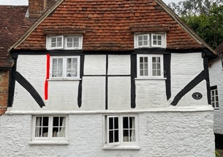

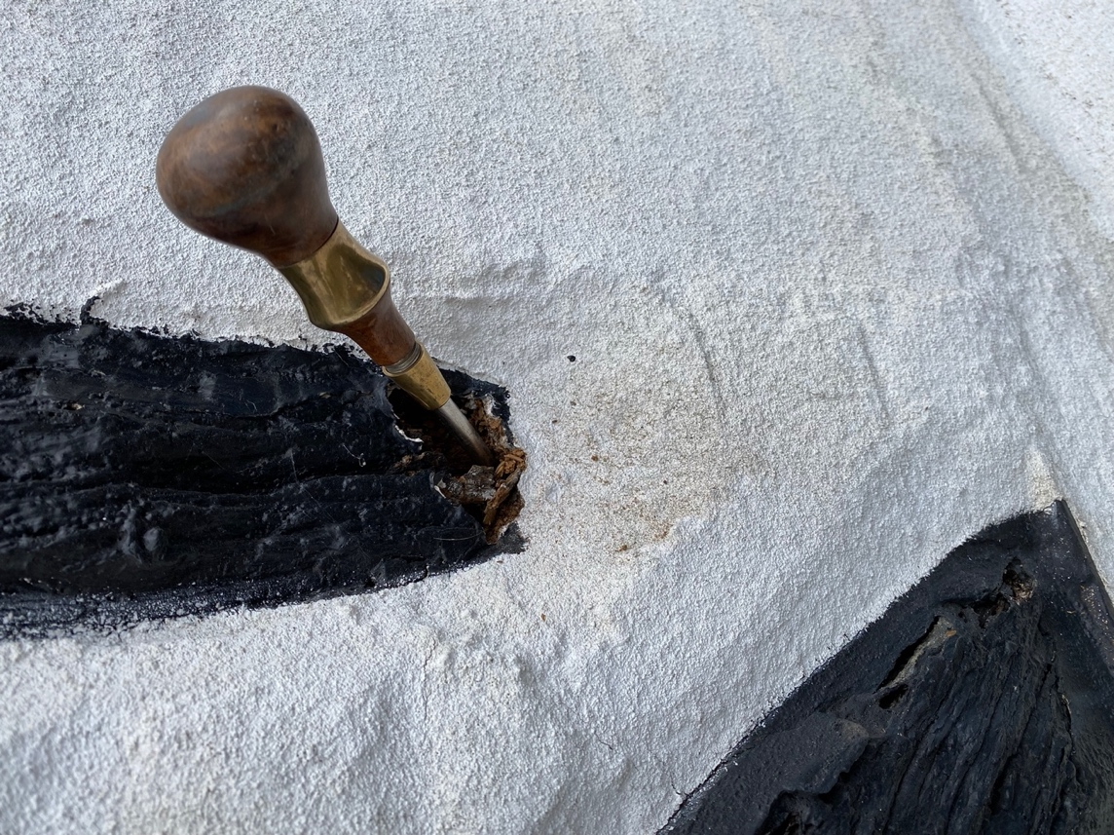
Figure 16, S1 Base.

Observations
We can see that the probe has penetrated full length showing that the base of the stud where it meets masonry has decayed full thickness.
Studs are secondary components and not structural, however, water ingress will be occurring where the decay exists.

Suggested remedial action
(See 10.6)

Estimate £150 + VAT

S2
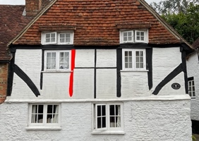

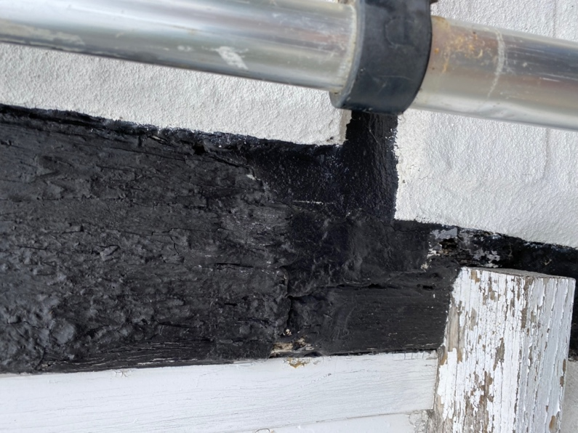  Figure 17, S2 at window sill. | 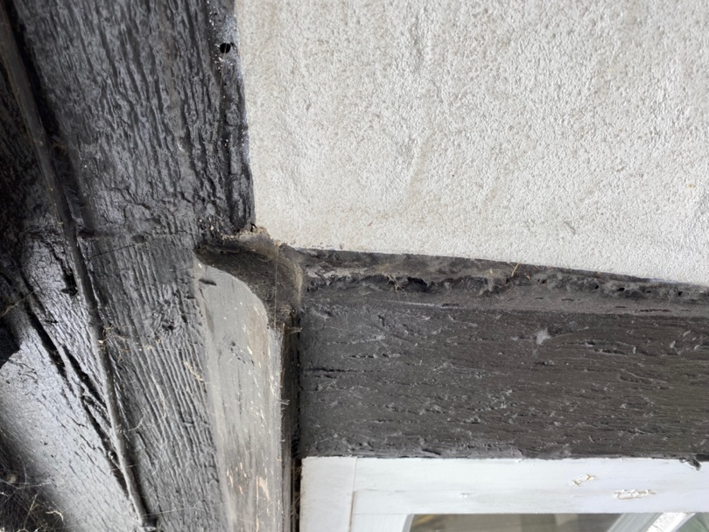  Figure 18, S2 Top.

Observations
Top
We can see that there is a timber cover over the historic timber which is evident from the differing level of the surface.
It was beyond the remit of our investigations to remove this timber cover, but experience would suggest that this board is likely to be covering decay in the timber stud.

Suggested remedial action
Remove timber cover board then starting at the most deteriorated area, decayed timber should be removed to a depth of sound timber. Then all decayed timber locally should be removed to the same depth to establish a mating surface for a timber patch. Then a suitable piece of timber provided [see section 13 below] and shaped just larger than the area revealed. The host timber can then be scribed to accommodate the patch and the patch glued into place. Once the glue has set the surface can be trimmed flush.

Mid section
We observed decay in the stud local to and surrounding the window sill. This is a longstanding issue as there is a timber patch [which although unlikely may alternatively be the result of a change in sill size or location] and considerable mastic.

Suggested remedial action
Starting at the most decayed area, decayed timber should be removed to a depth of sound timber. Then all decayed timber locally should be removed to the same depth to establish a mating surface for a timber patch. Then a suitable piece of timber provided [see section 13 below] and shaped just larger than the area revealed. The host timber can then be scribed to accommodate the patch and the patch glued into place. Once the glue has set the surface can be trimmed flush.

Estimate
Estimated £1200 + VAT

S3, S4, R1 and Panels 4 and 6
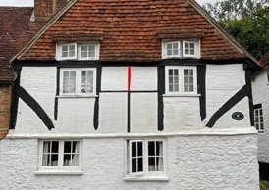 | 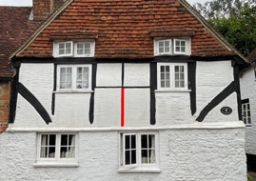 | 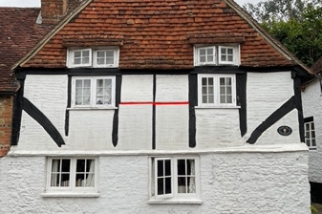

Observations
Because of the size and form of these timbers, I suspect that these are later timbers, inserted to replace decayed or due to a change the arrangement of historic timbers.
We can see that there is considerable distortion to the face of these timbers and there is cracking along the margins with the panels. The rail R1 appears to be ‘crushed’.
Panel 6 has dropped, evidenced by the horizontal crack at the head and at the top right. This is further evidence of decay in the horizontal rail R1.

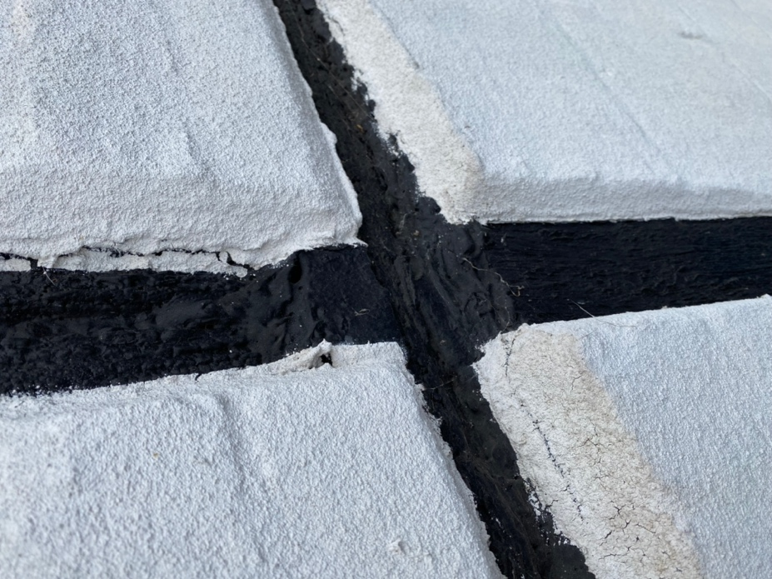  Figure 19, Intersection of S4, S5 and R1 | 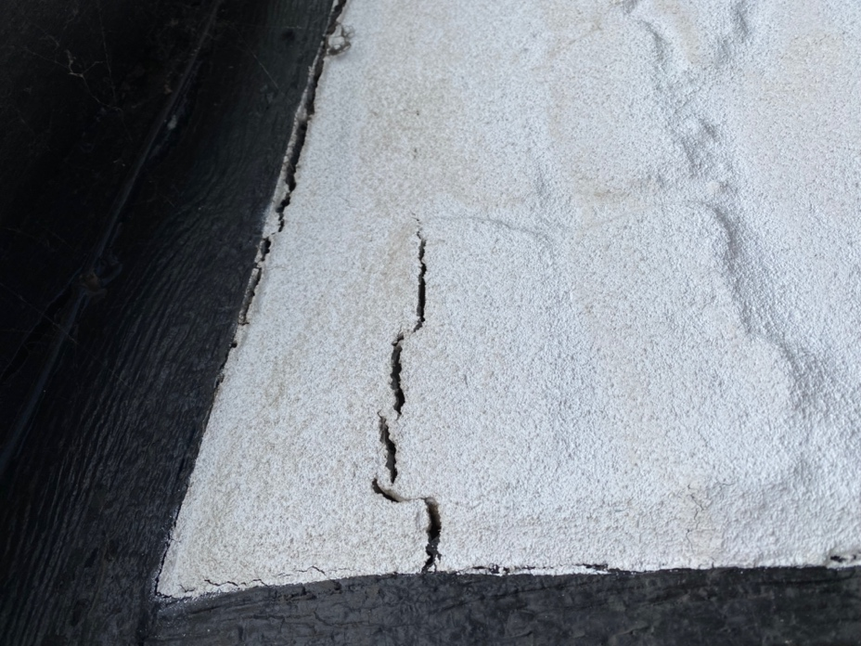  Figure 20, Panel 6

Suggested remedial action
Remove sufficient mortar from the bed joint at the top of the rail to accommodate a strong boy. Once strong boy has been fitted remove mortar from the bed joint at the head of the panel. Using the Acro’s, lift both panels as much as possible. Remove the rail and studs. The timbers should be assessed for their integrity and either replaced or repaired. The joints can then be re-mortared with non-hydraulic lime. The internal lining will allow this work to be carried out without disturbance to the internal space.

Estimate £2000 + VAT

S5
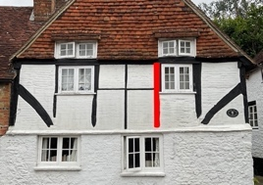

Observations
This timber appears to be a replacement as the connection at the head is different, being a shiplap and not a mortise and tenon. Although it appears solid, when tapped, it sounds hollow suggesting internal decay.

Suggested remedial action
When the panel P6 is removed, this timber can be more fully assessed and if found to be decayed then the appropriate action taken depending upon the extent. However, if found to be severely decayed it may be necessary to remove panel P7.

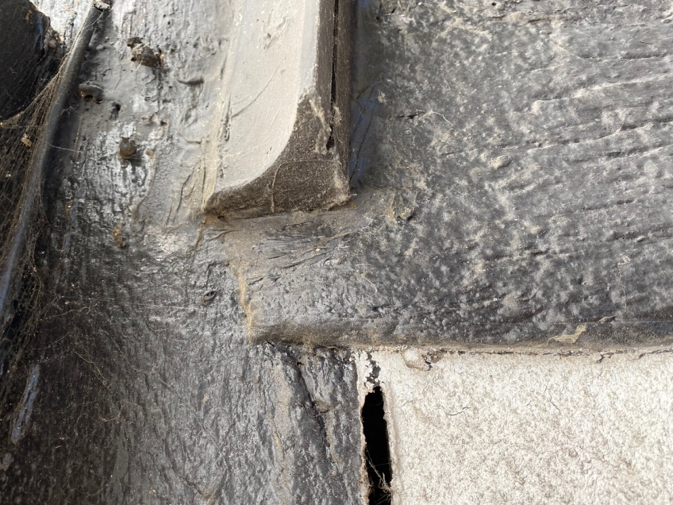
Figure 21, S5 Top.

Estimate assuming it needs replacement

£2300 + VAT

S6
See p 20

Tiebeam

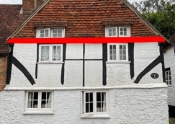

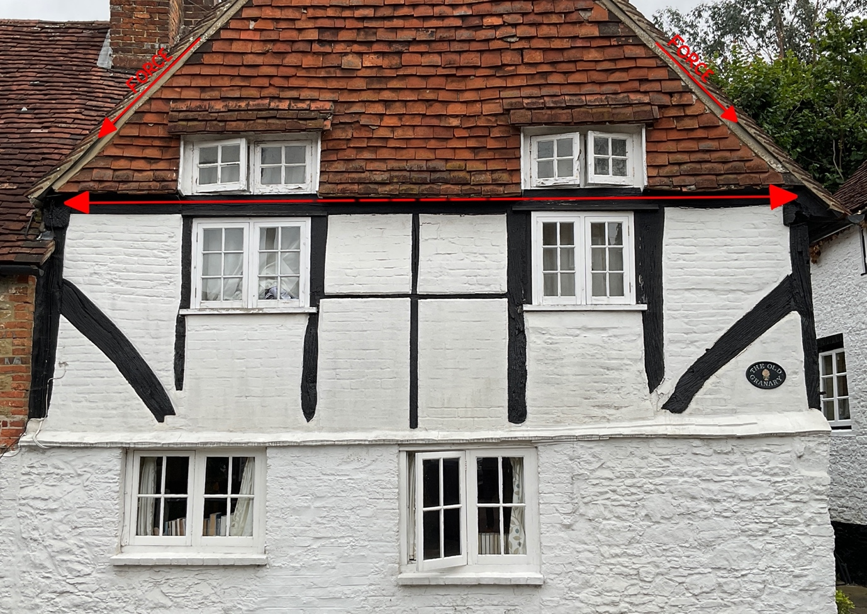
Figure 22, Forces acting upon the Tiebeam.

TB1
Tie beams are one of the few principal structural timbers in a historic timber frames that is in tension. i.e., it is resisting outward thrust at the eaves. [See Figure 22, Forces acting upon the Tiebeam. It is therefore vital that this timber is in good condition and that appropriate structurally engineered repairs are carried out.

Observations
This timber appears to be covered in some form of mastic and possibly some form of filler, particularly over W2. however, however, no decay was observed. In addition, over both windows W1 and W2 a drip has been created. I suspect that this has simply applied to form an impervious surface and seal to the drip.

Suggested remedial action
Although there was no obvious decay obvious, there may be decay hidden beneath the drip or under the very considerable mastic. When the other work is carried out, I suggest that the drips are removed and some of the mastic scraped off to determine the condition of this timber.

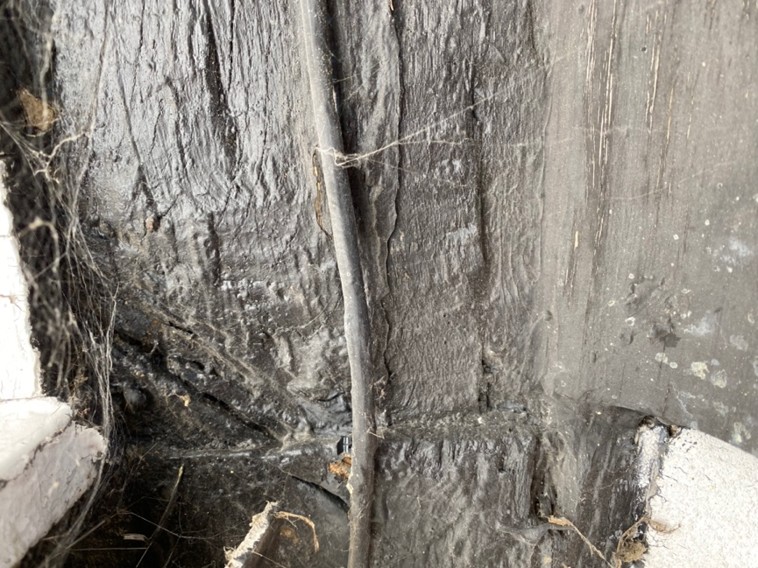  Figure 23, Tiebeam above window 1. | 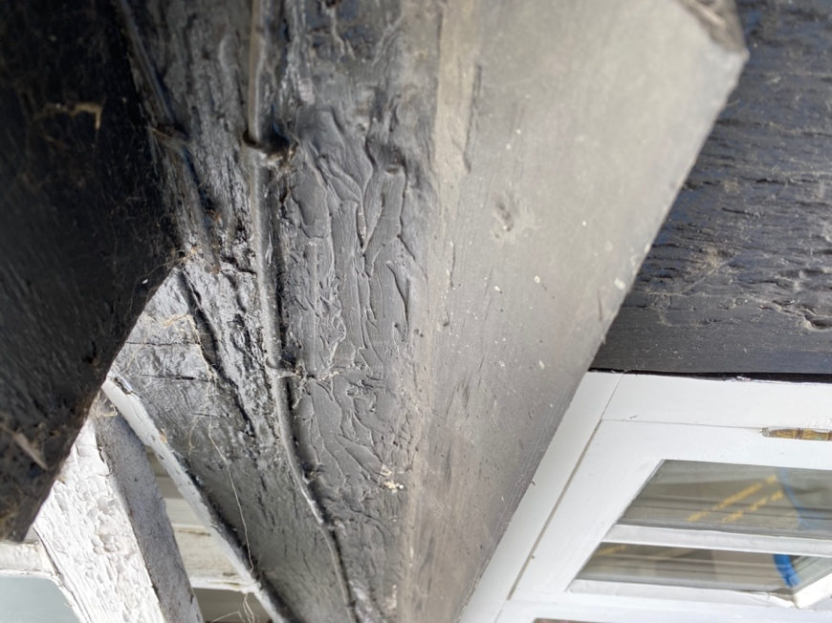  Figure 24, Tiebeam above window 2.

Rails
R1 see p25
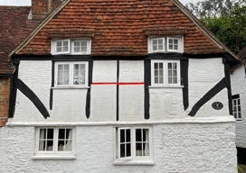

Panels
Observations
All of the panels in this elevation are formed of brick set in stretcher bond pattern.
There appears to be various brick sizes and quality suggesting that the panels replaced other panel infill, most likely wattle and daub, as a when the panels deteriorated.
The condition of the brick is difficult to ascertain as it is coated in a modern exterior masonry paint. But the surface texture in some areas would suggest that there are many bricks with deteriorated or spalled faces.

As described above, panels 4 and 6 have dropped due to decay in Rail R1 but P9 also shows a gap along the head. This gap indicates that the timber resisting downward forces has decayed along its upper surface.

Suggested remedial action
In this instance, because the drop is quite small and the panel large. It may be possible to support the panel, scrape out the decayed timber along its upper surface and along the margin with the panel. Then fill all gaps with non-hydraulic lime mortar.

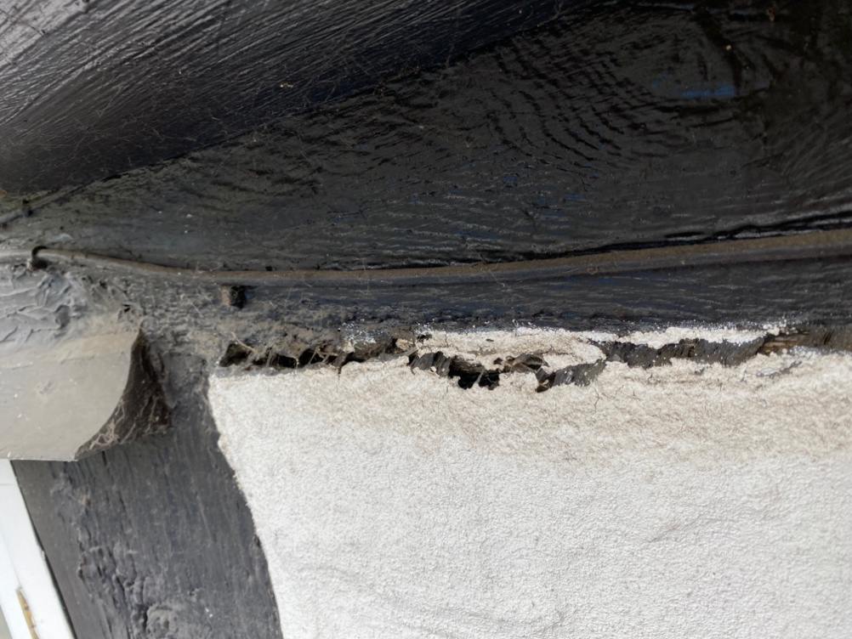
Figure 25, Head of P9 showing gap

Estimate
Estimated in the region of:
£600 + VAT

General points concerning repairs
- All new timber should be dry and match the original for species, which I believe to be oak.
- All new timber should contain replicated mortises peg holes, stave mortises, carpenter’s assembly marks etc even where they are currently redundant.
- All structural adhesives should be West system 2-part epoxy resin.
- The heads of all metal fixings used should be hidden with an appropriate size timber plug.
- The margins to all timbers should be sealed with non-hydraulic lime mortar preferably mixed with hair.
- Even with extreme care there will be disturbance to the internal plaster work adjacent to the works being carried out which the contractor may not be aware of it at the time of occurrence. This should be made good before completion.
- Lime patch repairs should be Non-hydraulic class 1 or feeble lime putty mixed with coarse aggregate and hair, this can be coloured with earth pigments to harmonise with timber.
- The prices given include all work and materials required to resolve each issue.

Conservation strategy
HBC&R believes that good conservation should be based upon a respect for the existing fabric; involve the least possible physical intervention, which should therefore result in the least possible loss of material of cultural heritage value. Where possible, we use reversible processes to allow the widest options for future development or the correction of unforeseen problems, or where the integrity of the resource could be affected. We believe that the building's story should be legible, hence; that replacement or missing parts must be distinguishable from the original so that restoration does not falsify the artistic or historic evidence. This does not mean that new work has to be radically different from that existing, just that it should not be hidden; some might say "honest". However, these repairs should be in harmony with the structure, and as such incorporate appropriate materials and utilise suitable methods.

As a general principle, completed repairs need to fulfil their structural function but also retain the maximum amount of historic fabric, whether the repair uses timber, steel, resin or other strengthening material, it’s impact will need to be minimised and discreet, if necessary, by slicing off historic timber facings and re-applying them to new or modern materials. Where modern re-enforcing materials have to be used, (for example, where a timber repair may mean the loss of more than acceptable amount of historic fabric or where a repair will not be seen and an economic judgement has to be made) they should be simple, discreet and effective in their design using non corrosive materials and fire protected.

Our general conservation principles

General
It is important to diagnose the problems that have caused the deterioration of the building through a structural assessment and or condition report. For the most part, problems with historic buildings, and in particular, timber framed buildings, can be traced to decay due to the ingress of water or failure due to ill-judged alterations or interventions. These must be addressed before or at the same time as the repairs are carried out, as unless these are resolved the problem will continue, even after repair.
It is important not only to deal with each individual problem but to take a holistic approach to the building, not only in assessing the problems, but also when considering the remedies, for example; a timber member in need of repair, may be repaired using a suitable in-situ method if it is the only repair required, or, it may be dismantled and repaired using a different technique if the whole frame needs repairing.
No attempt should be made to conceal repair work, but it should harmonize with the original fabric.

The type and extent of repair should consider the following factors.
• Only failed materials should be replaced
• The position within the frame
• Structural forces applied to the member or joint
• The flexibility required of the joint or member
• The visibility of the repair in the finished building
• Character of the building
• Longevity of the repair
• Its historic value (age, rarity etc)
• The amount of material being removed
• The effectiveness of the repair, structurally and visually
• Environment of the repair
• Use of the building i.e. restored to original use or upgraded to new use

All replacement materials should be suitable for their intended use, but match the original for type, size, colour, texture, style and method of fixing.

All materials and proposals should be approved by the Local Authority Conservation Officer before any work starts

Dismantling
Dismantling should be considered the “last resort” and should be kept to a minimum, as dismantling usually brings about the ppotential for further damage to the existing historic fabric, both of the frame, panels and other materials.

Workmanship
All work shall be reproduced to match the quality, size, type, style and material of the original, in all respects.

Timber

Decay and infestation of timber
Timbers showing signs of fungal decay and infestation of insects should be assessed for it's reduced structural performance. Unless timbers are identified as failing, they should be retained. Generally, timbers removed from the source of moisture and dried will not continue to degrade.

Replacement materials specification
Every effort should be made to retain all material contained in the fabric of the historic building, but where timber has to be replaced either completely or in part, the replacement timber should be new and of the same:

• Species
• Dimensions
• Square-ness
• Grade (quality)
• Grain, (on braces etc it should follow the same pattern as the original as they often
follow the curvature of the timber.
• Conversion type
• Moisture content
• Speed of timber growth
• Shape, this should include softening the edge of spliced in timber to reduce the
visual abruptness of a new piece
• Wane, its shape and position on the piece.

As a general principle, completed repairs need to fulfill their structural function, but also retain the maximum amount of historic fabric, whether the repair uses timber, steel, resin or other strengthening material, its impact will need to be minimized and discreet. Where modern re-enforcing materials have to be used, (for example, where a timber repair may mean the loss of more than acceptable amount of historic fabric or where a repair will not be seen and an economic judgement has to be made) they should be simple, discreet and effective in their design, using noncorrosive materials. Bolts, nails, and other fixings should be similarly hidden beneath plugs and facings etc.

Where possible, timber repairs should be repaired with timber, (following guidance from the Replacement timber specification above).

Brick

New work
Where brick work has to be dismantled and re-done. Any existing brick work should be carefully recorded before dismantling and setting aside for re-use. Where panel infill is concerned this should be on a panel by panel basis so that the same bricks can be re-used in the same panels.
New reclaimed bricks should be procured and matched for size, colour, texture and hardness.
The new mortar should be matched to the original in type, colour and texture However, it be noted that new work will look different as old work will have aged being coloured by dirt and micro plant growth.

Repairs
Only spalled, broken or missing bricks should be replaced. Where possible defaced bricks can be turned around (so long as only one side is required to be visible). Where bricks cannot be turned around, new bricks should be procured that match for size, colour and texture.

Re-pointing
The constituents and proportions of the mortar used to bed the bricks should be carefully analysed, matched and approved before work can commence. I would recommend a sample patch is prepared so that we can clarify final details of the specification, demonstrate the standards of workmanship and finish, and provide a control sample for guidance of the rest of the work.
Following conservation principles there should be a policy of minimum intervention (maximum retention) of historic material and we would recommend the replacement of mortar only where;
- Original lime mortar has failed.
- Original lime mortar has been replaced with cementitious mortars.
- Alterations have taken place and incorporated cementitious mortars.
- Bricks are broken or deep holes drilled.
- Where pipes or cables exit/enter the bricks surface.
The removal of mortar should be carried out using hand tools and not electric grinders which can easily damage bricks even in experienced hands and when great care is exerted.
Cementitious mortars can be very hard and difficult to remove but where cementitious mortar does exist in this building, we would only recommend its removal if this can be done without damaging the surrounding bricks.

Recommendations
If possible, all modern applied paints should be removed from both the timbers and the internal and external panels. Ideally timbers should be left without paint finishes and panels may be painted with a lime or clay-based paints to allow the evaporation of moisture.
Most of the original timber pegs have either decayed or have been removed, and because these pegs hold the joints together and could help an interpreter to understand the building, they should ideally be replaced with new oak pegs.

Timescales
Although there are issues found, non are desperately urgent. They could easily be scheduled into a programme of repair and maintenance over several years.
Combined, the recommended intervention would take approximately 2 and a half weeks to complete.
HBC and R Ltd always have a busy workload, but at present if required with planning we could be available to undertake the recommendations in the summer of 2022.

Conclusion
The Old Granary is a beautiful and interesting building that has great history yet to be discovered. Whilst it may be worrying to some to have identified areas of concern, the issues found are relatively small, pose no immediate threat to the integrity of the building and now known, their repair can be planned for.
With the information provided in this report, a programme of maintenance and repair can be prepared and acted upon over a period appropriate to the work and within a timescale acceptable to the circumstances and budget available.

Estimate

Estimate No. 671

Total Approx. £9,000 + VAT

Although comprehensive, it is possible that during the course the above remedial work being carrying out, other problems may be found to be necessary or that the extent of decay is found to be greater than expected, this should be discussed and the extent and amount agreed before work commences.

Yours Sincerely

Roland Locke MSc

About the author

Roland Locke has been working specifically in the conservation and repair of timber framed buildings for over 20 years.
Roland qualified with a Merit MSc in Timber Building Conservation from Bournemouth University in 2012

Roland is a member of the following relevant organisations:
Member of Society for the Protection of Historic Buildings (SPAB) since 2003
Associate member of Institute of Historic Building Conservation (IHBC)
Member of Wealden Buildings Study Group (WBSG)
Member [and contributor] of Domestic Buildings Research Group (DBRG)
Member of the Carpenters Fellowship (CF)

Web site: https://www.historicbuildingconservationandrepair.co.uk/

Historic Building Conservation and Repair Ltd, Director: Roland Locke MSc, Correspondence address: Steepwood Bungalow, Adversane Lane, Billingshurst RH14 9EG: Registered company No 8860281 : VAT No 201435168 : Web site: www.hbcandr.com

