Condition report and proposed conservation-based intervention for:

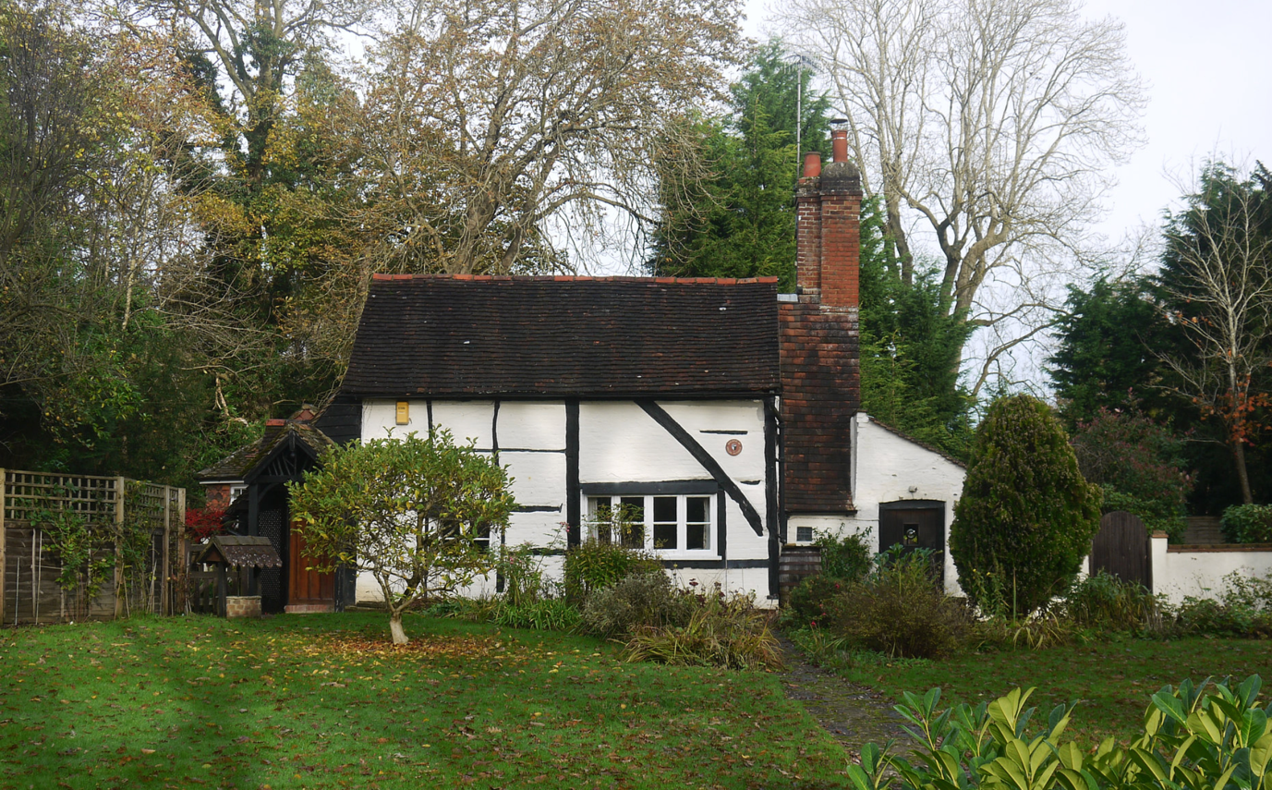

Laurel Cottage, Rectory Lane, Charlwood,
Horley, Surrey
RH6 0EF

Prepared by
Roland Locke MSc

August 2020

Table of Contents

1. Table of Contents 2
2. Table of Figures 4
3. Authority 5
4. Location 5
5. Historical Description 6
a. Listed Building Description 6
b. Domestic Buildings Research Group (DBRG) 6
c. Other Documents 6
6. Aims 7
7. Limitations 7
8. Use of this report 7
9. Survey methodology employed 7
10. Glossary of terms 8
11. List of timbers, their condition and proposed remedial action 10
Introduction 10
Lean-to North Exterior Wall 12
West elevation of the West Lean-to 14
Front / South 16
Outshot section left / West of porch. 16
Main range. 18
East Elevation 28
West Gable. 30
East Extension 34
12. General observations 36
13. Estimate 36
14. Joints that have failed or are failing. 37
15. Our general conservation principles 37
Dismantling 37
Workmanship 37
Timber 38
Brick 38
16. Notes to consider concerning repairs 39
17. Appendices 41
a. Appendix A 41

Table of Figures
Figure 1, Ariel View of Laurel Cottage. Google 2020 5
Figure 2, Image from “Early Houses of Charlwood”, J Harding. 6
Figure 3, Glossary of terms (details simplified for clarity). 8
Figure 4, Plan reference. 10
Figure 5, Exterior of North wall of West lean-to. 12
Figure 6, Interior of the north wall of the West lean-to. 12
Figure 7, Schematic of North wall of West Outshot. 12
Figure 8, West elevation [Outshot]. 14
Figure 9, Sole plate in West elevation of the outshot. 15
Figure 10, Schematic of South Elevation. 16
Figure 11, Outshot Section of South Elevation. 17
Figure 12, South Elevation, main range. 18
Figure 13, R5 revealed at P3 19
Figure 14, Brace connection with P4 showing decay and bulging render. 20
Figure 15, WP connection with P4. 21
Figure 16, Looking up. 21
Figure 17, Section 1 of BS1 22
Figure 18, Section 3 of BS1 23
Figure 19, Visible area of BS2 between the brace B1 and P4 24
Figure 20, Showing how the brace has twisted and rotated away from BS2 24
Figure 21, Revealed tenon on R5 to P3. 27
Figure 22, Part of the East Elevation. 28
Figure 23, East Elevation. 29
Figure 24, West Gable [above tie beam]. 30
Figure 25, Shows water trapping between the cementitious render and timber. 32
Figure 26, Showing how the lead has not been properly inserted into the bed joint. 32
Figure 27, No ‘welt’ on lead. 32
Figure 28, Cracks in the mortar bed joint. 32
Figure 29, Interior of West Gable, 33
Figure 30, East brick arch 34
Figure 31, Bulging brickwork above brick arch. 34
Figure 32, Inside of the brick arch. 35
Figure 34, Data sheet from BARD website. 43

Authority
The following survey of the named property was carried out at the request of the owner Mr Grahame Perfect by email.
Roland Locke carried out a site survey on Tuesday 11th August 2020.

Location

LAUREL COTTAGE, RECTORY LANE
The building or site itself may lie within the boundary of more than one authority.

County: Surrey
District: Mole Valley (District Authority)
Parish: Charlwood
National Grid Reference: TQ 24053 41271

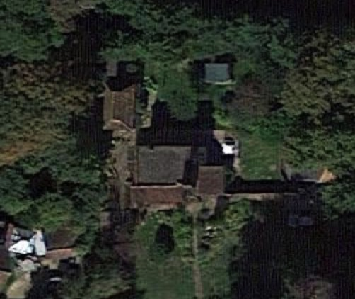
Figure 1, Ariel View of Laurel Cottage. Google 2020

Historical Description

Listed Building Description
RECTORY LANE 1. 5387 (north side) Laurel Cottage TQ 2441 5/33 II

2. C16 or earlier altered in C17 and in modern times. Originally just a 2-bay open hall. Probably later in the C16 the hall was divided to make a service room with bedroom upstairs and a smoke hood was inserted. In the C17 a chimneystack was added outside. One storey and attics timber-framed with painted brick infilling. Long passing braces. Tiled roof. Two casements. External brick chimneystack to right hand side. Later gabled porch to left hand side. Queen post roof. The chimney breast has open shelves for keeping salt. Pathway of Charlwood stone.

Listing NGR: TQ2405441270

Domestic Buildings Research Group (DBRG)

The Domestic Buildings Research Group (DBRG) surveyed Laurel Cottage in the 70’s and Joan M Harding produced a Report [No 12] a copy of which is available.

Other Documents
Laurel Cottage is described on page 58 of "Four Centuries of Charlwood Houses" Joan Harding. 1976.
Laurel Cottage is also listed on page 56 of “Surrey medieval buildings”, Peter Grey. 1974
And on page 26 of “Early Houses of Charlwood 1400 – 1840”, J. Harding.

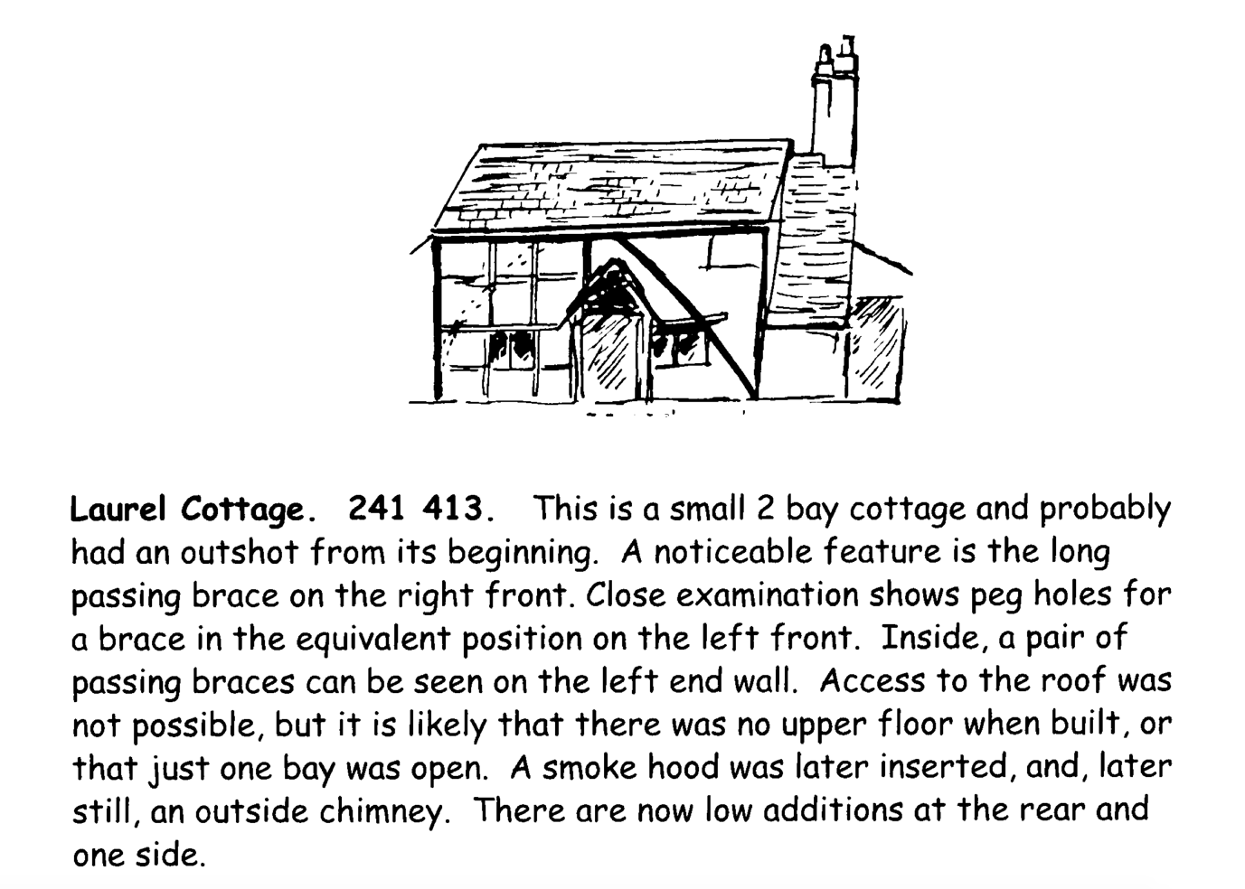
Figure 2, Image from “Early Houses of Charlwood”, J Harding.

Aims
The aim of this report is to provide;
- A condition report on the condition of principal and secondary timber members within a selected area.
- Provide an estimate for any repairs suggested.

Limitations
This survey was limited to the accessible principal and secondary hardwood structural timbers and panel infill in the North and East walls of the West outshot, South and visible area of the East walls of the main range of Laurel Cottage, Charlwood.
The condition of any concealed timbers or partially concealed timbers may be deduced from the general condition of other timbers and the structure in general. Only demolition or exposure work can enable the revelation of concealed timbers and their condition to be fully determined with any certainty, and this destroys the historic fabric intended of conservation. Specialist investigative techniques are therefore employed as aids to the survey. No such technique can be 100% reliable, but their use allows deductions to be made about the most probable condition of the fabric at the time of examination in assessing the extent of decay. Structures and timbers were not examined in detail except where described in this report, and no liability can be accepted for defects that may exist in other parts of the building. We have not inspected timbers or other parts of the structure that are covered, unexposed or inaccessible and we are therefore unable to report that any such part of the property is free from defect or in the event that such part of the property is not free from defect it will not contaminate and/or affect any other part of the property. No formal investigation of moisture distribution was made.
Absolute identification of timber species is only really possible by end grain analysis, this analysis should be carried at the remedial action stage and the appropriate timbers procured.
We were asked to survey and report on two elevations. We did not therefor survey and have not reported on any part of the rest of the building including the roof [apart from the gables].

Use of this report
This report is solely for the use of the addressee and the application of Listed Building Consent and shall not be reassigned to any other party, without the written permission of the author.

Survey methodology employed
The assessment of the timbers included in this report was primarily visual; however, a four-inch-long metal probe was employed to assess the depth of decay. Timbers were tested from outside of the building and the position and depth of identified decay plotted on a scale drawing to compile a thorough depiction of the pattern of decay.
A linen tester was employed to assess the size and shape of insect flight holes for determination of species and identification of fungal infestation was by visual examination.

Glossary of terms
As compiled in ‘Recording Timber-Framed Buildings: An Illustrated Glossary’ 1996, Council for British Archaeology. York

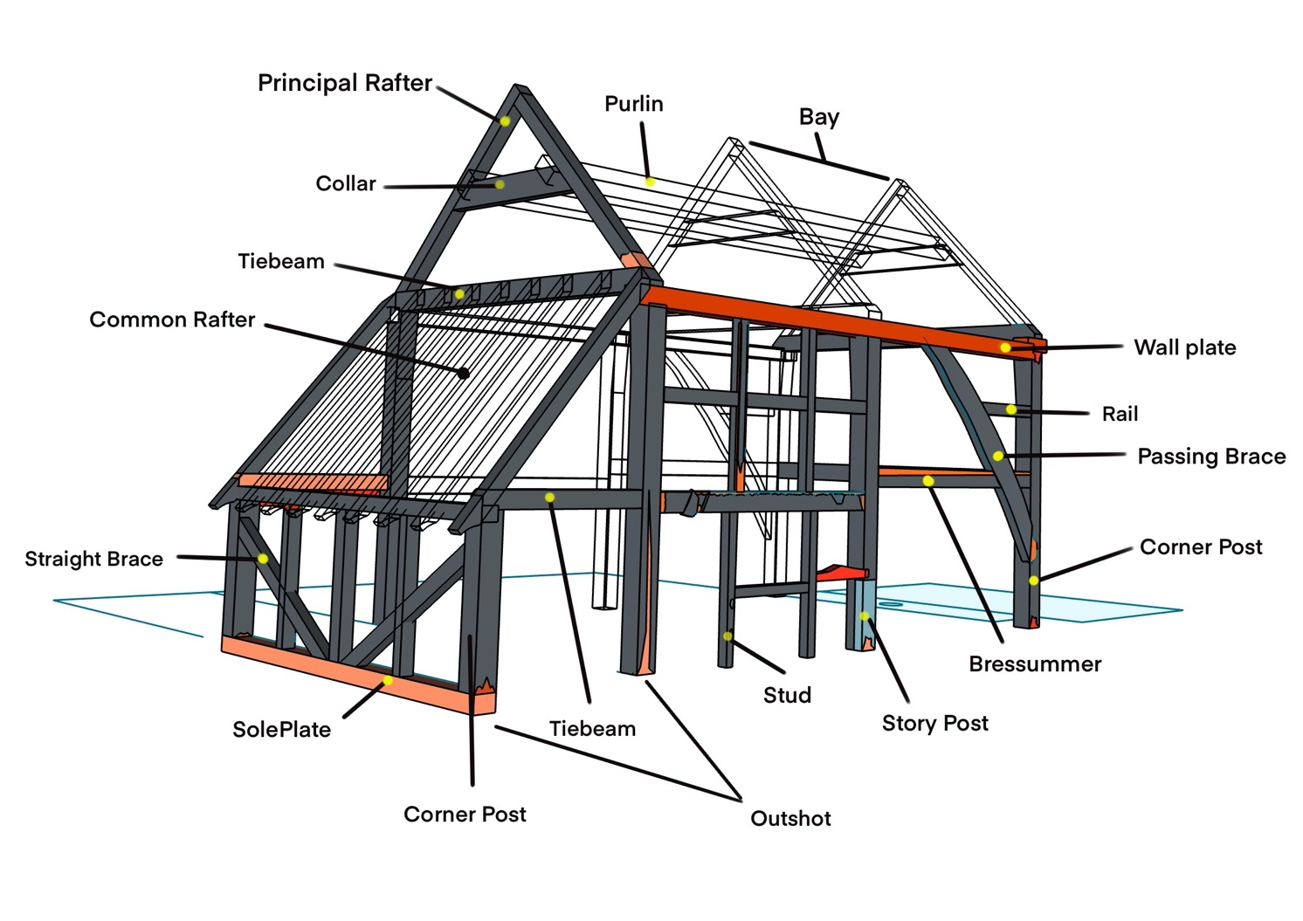
Figure 3, Glossary of terms (details simplified for clarity).

See Figure 3 for the position the following timbers are located in a building.

Brace (B)
A subsidiary timber curved or straight upward, normally running between vertical and horizontal principal members of a frame which may be distinguished by its direction in relation to the post, e.g. Downward brace, upward brace.

Passing brace (B)
As above but crosses a primary structural timber.

Post (P)
A vertical timber member, usually substantial and forming part of the main frame.
A principal structural timber forming the main frame of the building, it carries loadings from the roof and walls down to the ground.

Posts in historical timber frames often have a swelling called a Jowl which allows for the connection of three principal timbers; the wall plate, the tie beam and the post itself.

Purlin (PL)
A longitudinal member orientated in the plane of a roof slope and supporting common rafters.

Rafter (RF)
An inclined timber, usually one of a pair, which supports the laths under the roof covering.

Common Rafter (RF)
Rafters of uniform size regularly spaced along the roof, or intermediate between principals; a pair of common rafters is a couple.

Jack rafter (JR)
A shortened common rafter running between eaves and hip rafter or hip and ridge or ridge and valley.

Principal rafter (PR)
An inclined timber forming a member within a truss which may or may not additionally act as a common rafter.

Hip rafter (HR)
A rafter set and at the corner of a hipped roof at 45 degrees to the main frame, to take the upper ends of jack rafters.

Rail (R)
A subsidiary horizontal timber member of a wall frame set between posts or studs.

Midrail or Girt (G)
A horizontal timber member of a wall frame set between posts and centrally located in a storey or open hall.

Sole plate (SP)
A principal horizontal timber member at the bottom of a framed wall into which posts and studs are tenoned into.

Stud (S)
A subsidiary timber member, usually vertical, in a framed wall or partition.

Wall plate (WP)
A principal horizontal timber member at the top of a framed wall into which posts and studs are tenoned into and which support the end of the rafters.

List of timbers, their condition and proposed remedial action

Introduction

References for timber members
Figure 4 below is a plan view illustration of the frame discussed in this document. It has been created to provide a reference for type and location of timber components discussed within this document. Areas discussed have been indicated in RED in this drawing.

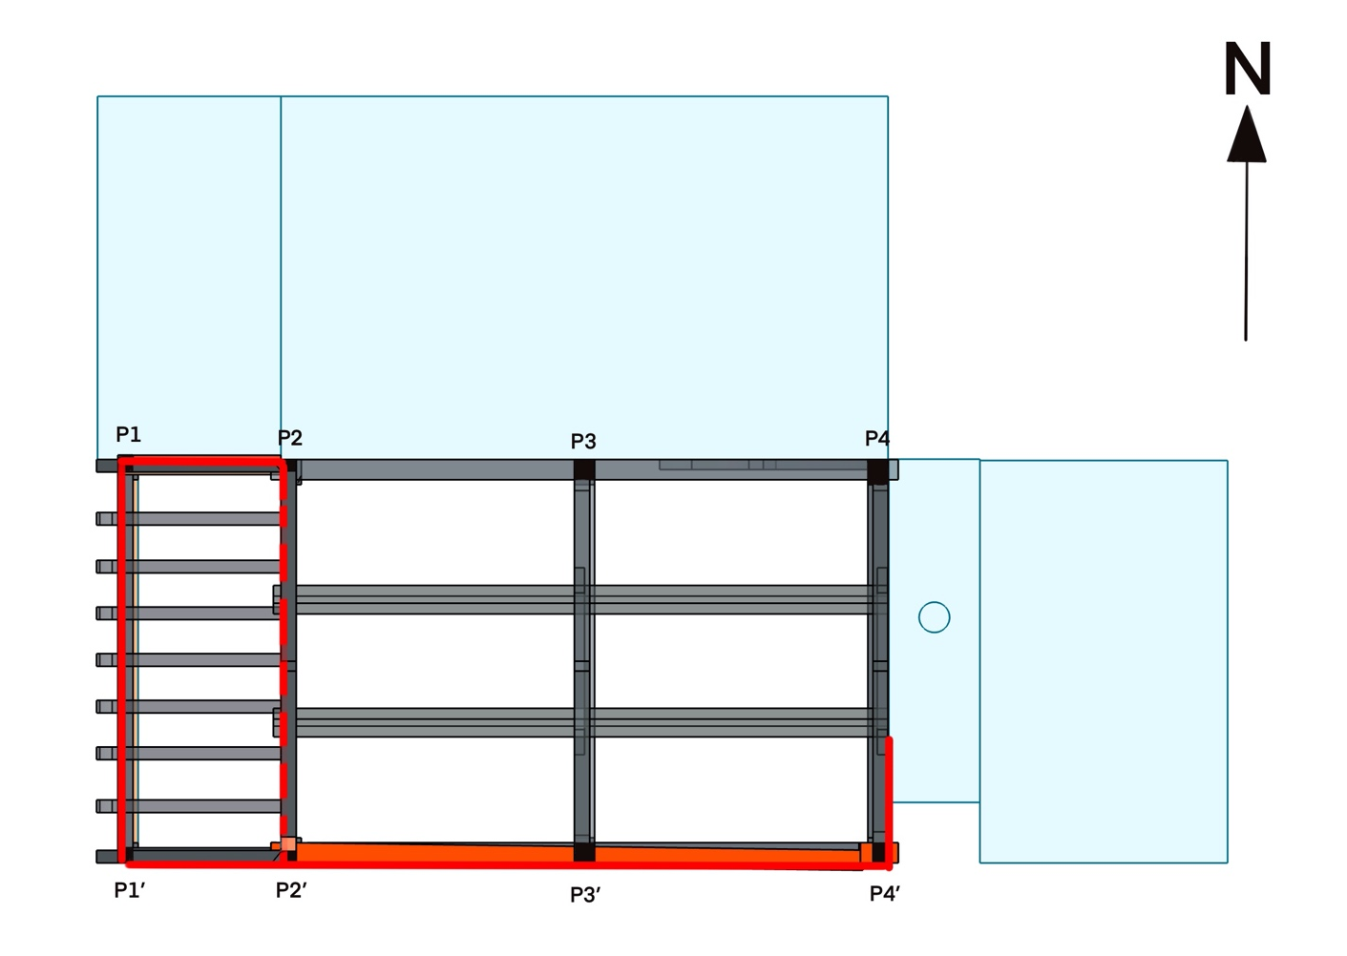
Figure 4, Plan reference.

The building has been divided up into 2D frames or elevations and labelled by their orientation relative to North.
Within each elevation, each timber has been assigned a reference according to its type; as in Section 10.

Where there are multiple members of the same type within a frame, these have additionally been assigned a number.
In the longitudinal frames (elevations) the number sequence starts at the West.
In cross-frames the references start in the North.

Example; W,B1 = West, Brace one.

A corresponding reference appears as a heading for the description, condition report and proposed remedial action for that timber in the text below.

Each frames description starts with an image or drawing of the frame in question that clearly shows the timbers and their designated reference.
Timber components not included in this document may be indicated in outline only.

References for location and extent of decay
The drawings also show any areas of concern.

Key to areas of concern are highlighted in colour;
- Light Orange indicate areas of suspected decay.
- Orange indicates partial thickness decay.
- Red indicates full thickness decay or a failed timber.

Additionally, Images may be included which illustrate a particular area of concern or particular timber. In some instances, drawings may be included that describe a suggested intervention.

We have illustrated and commented only on defects where we can see them. But other timbers are included in the drawings.

Lean-to North Exterior Wall
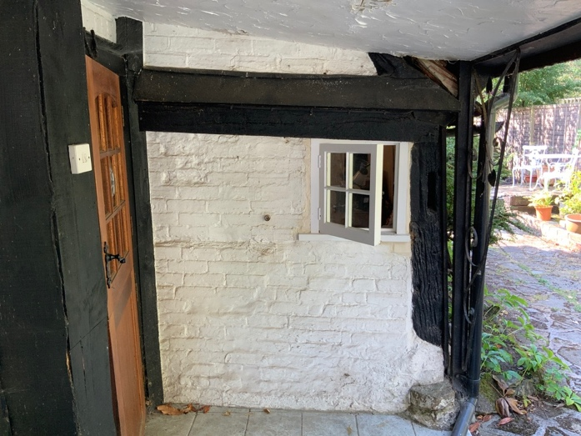  Figure 5, Exterior of North wall of West lean-to. | 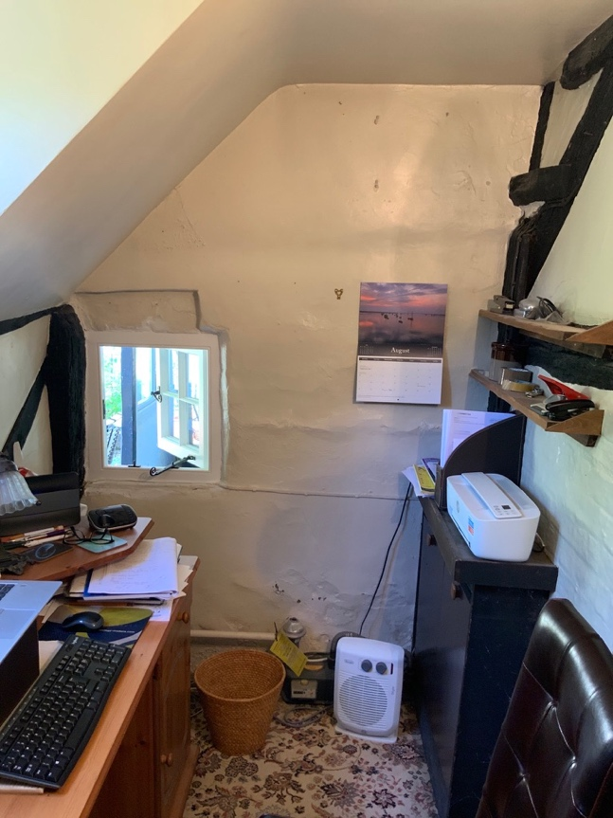  Figure 6, Interior of the north wall of the West lean-to.
Figure 7, Schematic of North wall of West Outshot.
The North wall of the West Lean-to is constructed predominately of single skin brick. With a modern softwood casement window, the aperture clearly having been altered to accommodate.

The exterior of the wall is covered with modern paint.
The interior is plastered in lime which is painted with modern paint.
- The base of the wall is showing signs of rising damp: blistered paint and plaster.
- There is a deformation in the plasters surface approx.' halfway up where there is some cracking of the surface plaster.

The extant timber components that remain [1] a post and [2] tie beam of timber which has been supplemented by a second piece laid over [3].
1. P1, Post, Oak.
The base of the post is covered with lime mortar which has subsequently been painted with many layers and types of paint.
The paint layers have become separated from the degraded lime causing some cracking. The base of the post itself appears a little soft but remains serviceable.
2. TB, Tie beam
The tie beam is hidden by what appears to be a supplementary tie-beam. It is nailed at the right where it laps the corner post P1. There is little or no integrity in this timber. It is loose both to the wall and the post it is nailed to. The top edge is deteriorated, particularly at the extreme right end. A length of weatherboarding covers the upper face, covering the most decayed face and preventing more detailed examination.
3. PR, Principal Rafter
There is a fragment of principal rafter which is mostly covered by bitumen felt which prevents further examination.

Suggested repair
- Remove the modern paint to both interior and exterior wall surfaces, plaster with non-hydraulic lime plaster and repaint in a breathable paint.
- Remove the supplementary Tiebeam, investigate the condition of the Tiebeam and repair as necessary.
- A cost cannot be determined until the investigation has been carried out.

West elevation of the West Lean-to
Figure 8, West elevation [Outshot].
P1. Post 1
Soft in places, with an area at the top of the post filled with mortar.

Suggested repair
Remove weather boarding on the west elevation and investigate extent of decay in sole plate. Repair this post at the same time.

S1. Stud 1
The top of this stud is decayed and adds nothing to the integrity of the wall.

Suggested repair
Fix a small metal bracket to re connect the stud and wall plate.
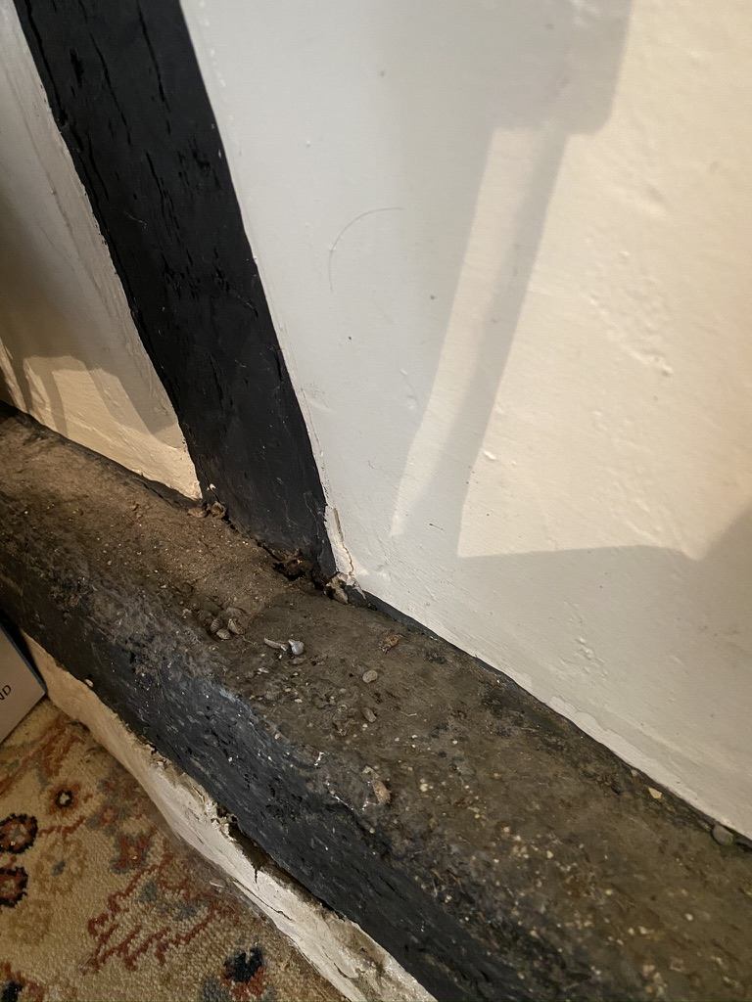
Figure 9, Sole plate in West elevation of the outshot.
SP. Sole-plate
Although this timber appears sound, and my probe does not penetrate the surface significantly. There appears to be distortion of the upper face [squashing] all the way along and I suspect that the outer face and core are decayed. The sole plate ‘area’ on the exterior is covered with bitumen felt beneath which there is cementitious mortar covering the sole plate.
The exterior of this elevation is covered in a waney edge weatherboarding which prevents further investigation of this and other timber components.

Suggested repair
An Invasive investigation should be carried out to establish if the integrity of this timber has been compromised.
Estimated cost to Investigate and fix a metal bracket to S1 = £890 + VAT. The climbing plant in front of this elevation will need to be drastically reduced or removed.

Front / South
Figure 10, Schematic of South Elevation.

Outshot section left / West of porch.

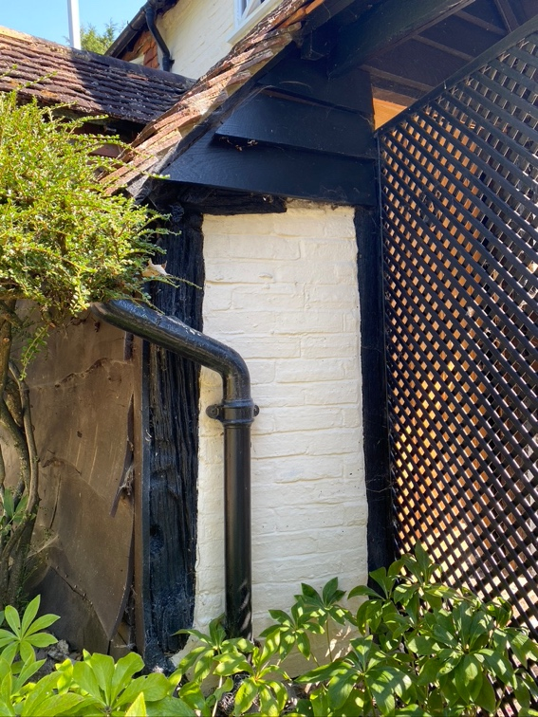
Figure 11, Outshot Section of South Elevation.

P1’. Post.
The very base of this corner post has decayed away leaving almost nothing supporting this post.
The crushing effect seen in the upper surface of the sole plate in the West wall may indicate that all loadings have been transferred to this area.

Suggested repair
Remove weather boarding on the west elevation and investigate extent of decay in sole plate. Repair this post at the same time. Costs can only be provided when the extent of decay in the sole plate has been determined.
TB1. Tie-beam
Only a fragment of the tie beam can be seen which appears solid, but the overall condition of this timber cannot be determined with removing the weatherboarding.

Suggested repair
Remove the weatherboarding assess the condition of the Tiebeam and repair as necessary.
Investigation Estimated at £220 + VAT

Main range.
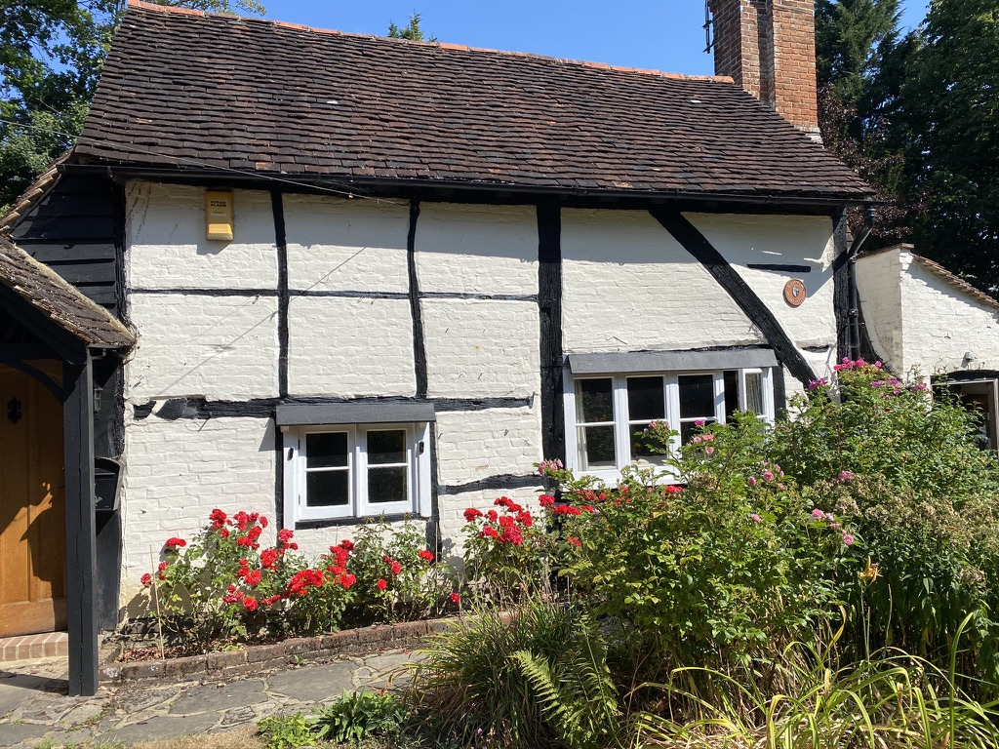
Figure 12, South Elevation, main range.
Posts.
P2’. Corner post South-West.
There is a large ‘cover-board’ rising up from the base which appears to have been fitted relatively recently. I suspect this is covering decay at the base and a fissure. The remainder of this post is covered over with weather board and cables, only fragments are exposed, and so further investigation was not possible.

Suggested repair
Remove cover boarding and investigate extent of decay. Repair as necessary.

Investigation only Estimated at £200+ VAT

P3’ Mid Story Post.
At the base [below the windowsill] the post has been replaced with cement.
At the margin between post and concrete, the timber has decayed leaving a void or very soft area.
The tenon from rail 4 is revealed due to decay at the side of the post.
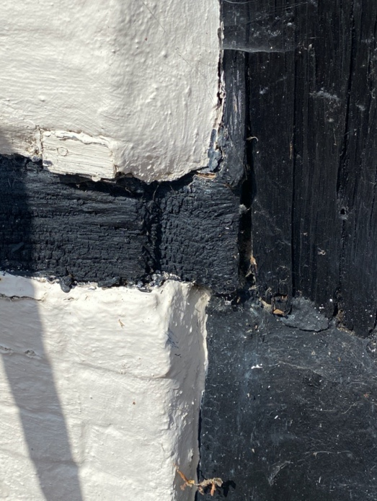
Figure 13, R5 revealed at P3

Suggested repair
Remove cementitious mortar and splice in new timber which should encase the tenon from R4.
Estimated at £1900 + VAT
P4’ South East Corner post.
The base has been under built in brick and a lead plate inserted.
which has resulted in further decay of the base of the post as a result of the post being in direct contact with the water that will accumulate on the surface of the lead.
In addition the timber has decayed at the connection with the brace.
The placement of the water but presents an additional splash area, where rain will bounce off the surface onto the fabric of the building including the post.
The top of the post has decayed where the wall-plate has decayed and failed.
I believe this post has dropped evidence for this can be seen in the internal first floor which dips in this area but also the render which has cracked bulges. See Brace B1 below.

Suggested repair scheme
- Provide scaffolding to enable access and a working platform.
- Remove the verge roof tiles and some of the eave tiles.
- It may be necessary to cut back some tile batten.
- Splice in a new timber horn to the wallplate/ principal rafter and tie beam.
- Replace any tile batten that has been cut back.
- Reinstate the eave tiles.
- Reinstate the verge tiles.
- Re grout the margins of the effected timbers.
- Does not allow for any internal making good if that proves necessary.

This repair should be carried out in conjunction with the repair of the tie beam and the principal rafter in the East elevation.

Estimated at £5,500 + VAT

B1. Brace

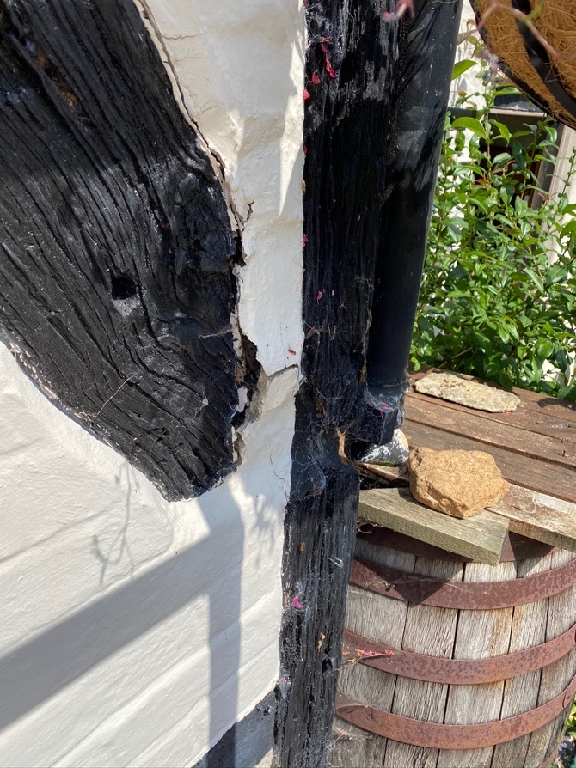
Figure 14, Brace connection with P4 showing decay and bulging render.

At the connection with the bressummer the brace has distorted and pulled away, rotated around the bottom tenon reducing / negating the integrity of the connection.

Suggested repair scheme
- Remove bulging mortar
- Splice in new dry timber to the bottom of the brace and possibly to the post.
- Fill margins around new timber with non-hydraulic lime mortar.

Estimated cost £1525 + VAT

WP. Wall-plate.
The wall-plate appears to be one continuous section and in remarkably good condition except for the Eastern end where it has decayed and failed.

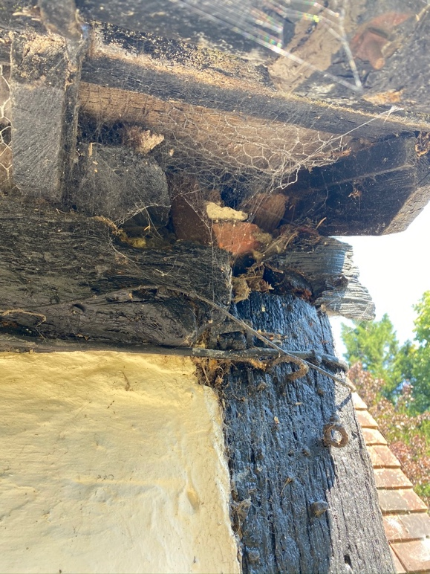  Figure 15, WP connection with P4. | 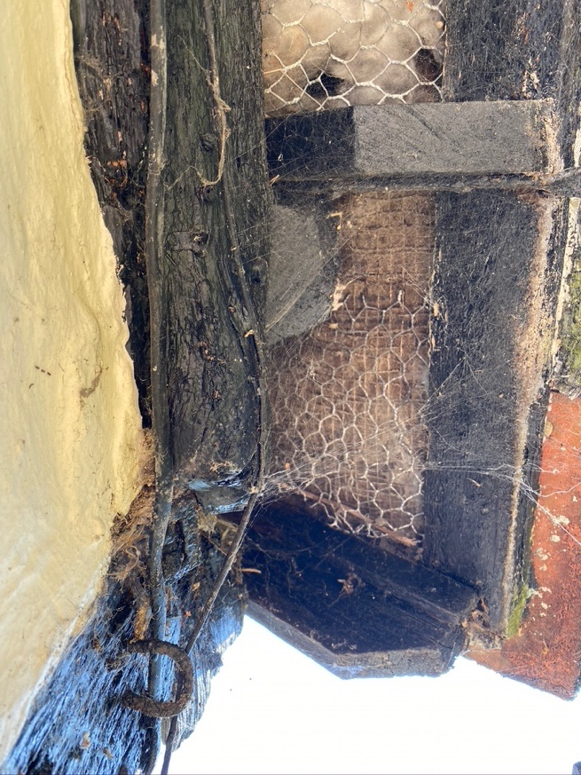  Figure 16, Looking up.

This has clearly been an issue for a very long time as there is an Iron strap restraining outward movement of the wall plate immediately over the post.
However, the rest of the wall plate has moved outward about 3" and downward about 4" Impact on principal rafter etc.

Suggested repair scheme
See P4’ above

BS 1. Bressummer.

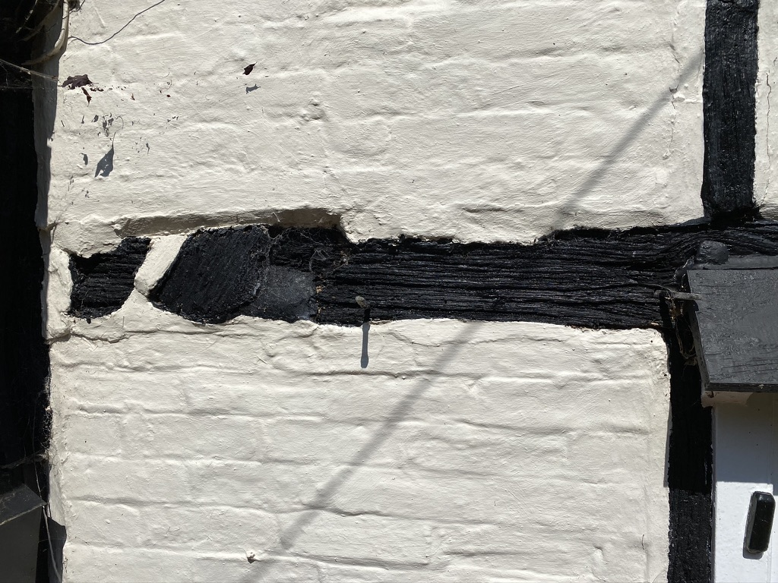
Figure 17, Section 1 of BS1

Section 1.
A. Possible decay at connection with corner post-this has been filled with cementitious mortar.
B. Connection with lost brace. Only a fragment exists of the brace revealing the mating surface of the bressummer.
C. The top edge of bressummer in this section is very soft and where decayed back, it has been filled with mortar, this should be removed, the timber checked and repaired if necessary and then the margin of the timber re-filled.
This is the case along the full length of this timber-

Section 2
Has a drip over the window which is filled with mastic where it abuts to the bressummer. The mastic has deteriorated and is allowing water to pass. In addition, where the timber has reduced due to surface decay. it has been filled with mortar and the paint covering is soft over.

Section 3.
In addition to the decay along the top edge-it has decayed along the bottom because the panel has moved forward or timber shrunk back-
The paint is exasperating the problem!
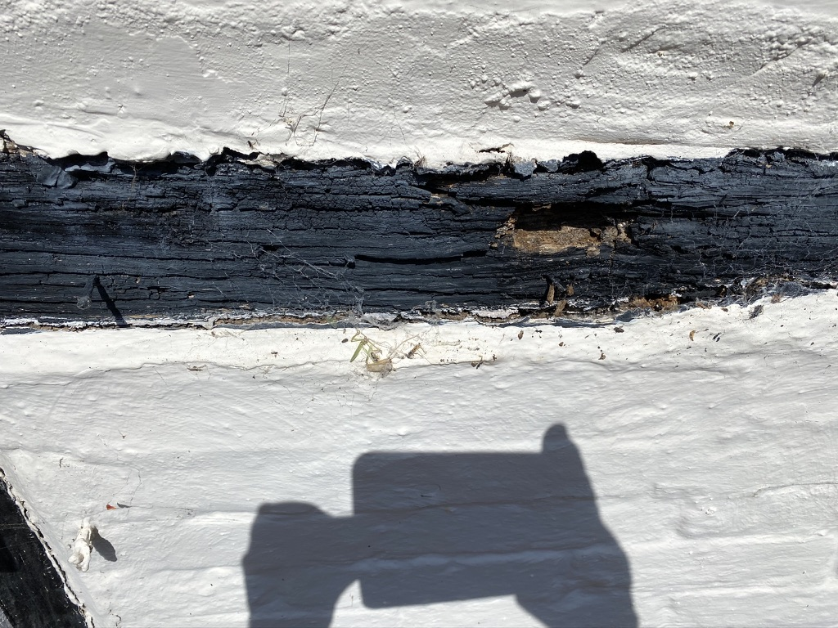
Figure 18, Section 3 of BS1

There is also a pocket of decay.
There is also decay where the top of stud 4 connects.

Suggested repair scheme
- Remove all mortar along the top and bottom edges of the bressummer.
- Remove the drip over the window.
- Splice in new timber where decay is found.
- Re grout edges with non-hydraulic lime mortar.
- Re-instate the drip.

Estimated cost £3000 + VAT

BS2. Bressummer 2.
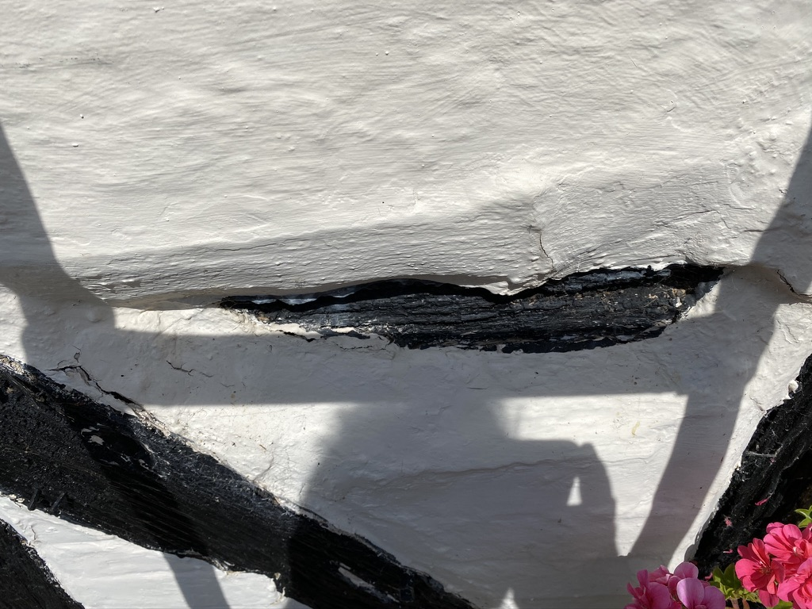
Figure 19, Visible area of BS2 between the brace B1 and P4
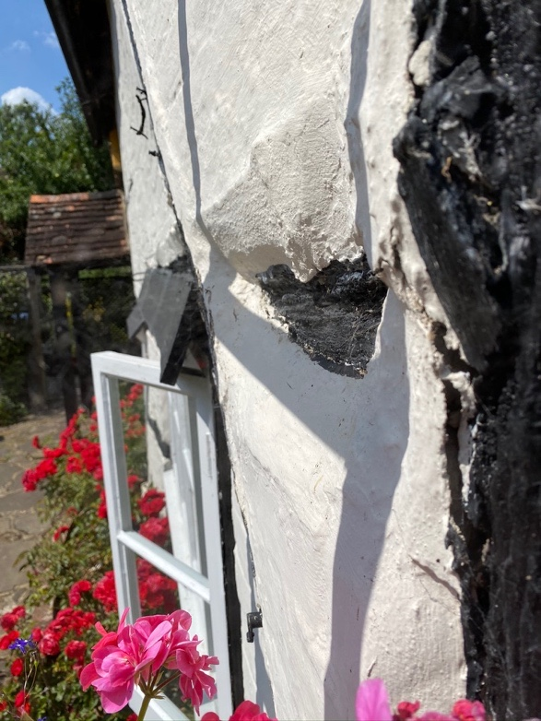
Figure 20, Showing how the brace has twisted and rotated away from BS2
This timber is predominantly obscured by both encroaching mortar and the drip over the window and as such it is difficult to determine its condition. However, probing upwards, under the mortar it appears soft and at the far right the timber has decayed back from the mortar leaving a large gap for water to collect.

Suggested repair scheme
- Remove all mortar along the top and bottom edges of the bressummer.
- Remove the drip over the window.
- Splice in new timber where decay is found.
- Re-instate the drip over the window.
- Re grout edges with non-hydraulic lime mortar.

Estimated cost £3000 + VAT

Studs.
SI, nailed on-Clearly a later change.
soft along its edges. and only tentatively connecting to Its neighbouring timbers. It sounds Very hollow at the base!

Suggested repair scheme
- Remove all mortar along the top and bottom edges.
- Splice in new timber where decay is found.
- Re grout edges with non-hydraulic lime mortar.
Estimated cost £1100 + VAT
S2. Again, nailed on and clearly a later change.
it has a deep fissure running full length which does not present any concerns.
S3. There are 2 deep cement filled areas below the windowsill and the width of this timber has been greatly reduced by encroaching mortar.
uncertain how soft it may be along its edges.

Suggested repair scheme
- Remove all mortar along the edges.
- Splice in new timber where decay is found.
- Re grout edges with non-hydraulic lime mortar.
- Estimated cost £1100 + VAT
S4. At the base there is both cementitious filler and decay
At the top where it connects with the bressummer
there is decay and no connection.

Suggested repair scheme
- Remove all mortar along the edges.
- Splice in new timber where decay is found.
- Re grout edges with non-hydraulic lime mortar.
Estimated cost £1000 + VAT
S5. Stud to the right of window- probably a modern timber but soft at the base where it sits on the lead.

Rails.
R1. There is little or no connection at left (P1) and mortar encroachment is causing a water trap.
R2- little or no connection at left (s1)
severe mortar encroachment-but not appearing to cause trap.
R3- Appears firm
R4. Rail beneath the window- poor connection to (S4)

R5. Tennon revealed at P3’ right. Severely decayed along its entire length.

Suggested repair scheme
- Remove all mortar along the top and bottom edges.
- Splice in new timber where decay is found.
- Re grout edges with non-hydraulic lime mortar
- Repaired in conjunction with P4’
R6. Rail beneath 2nd window--A modern timber with no connection F- visible] at either end!
R7. Small rail top right - mostly covered with mortar-soft / no connection with Ps.
Cracking lines in mortar above and below-suggesting decay Sounds hollow.

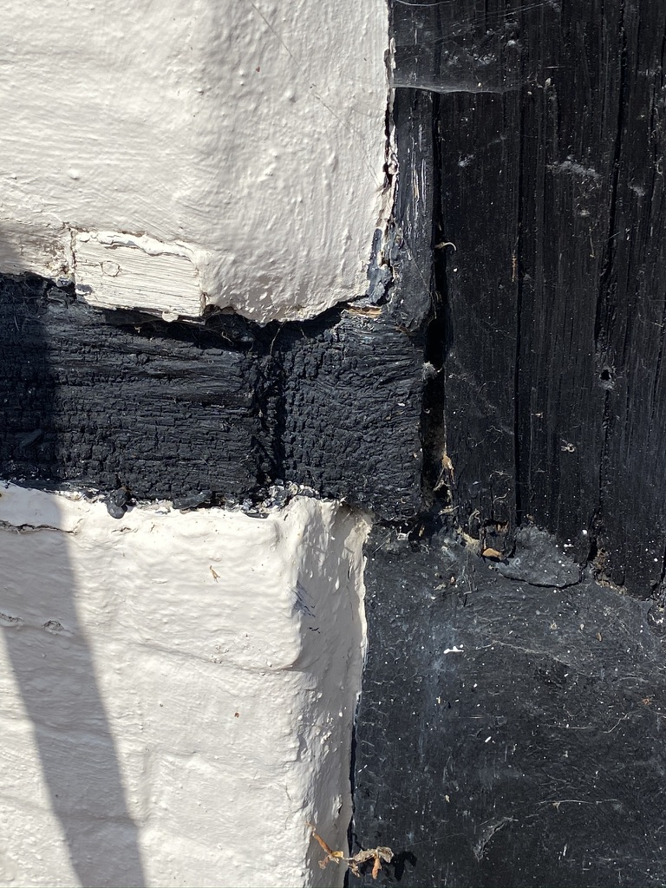
Figure 21, Revealed tenon on R5 to P3.

Suggested repair scheme
- Remove all mortar along the top and bottom edges.
- Splice in new timber where decay is found.
- Re grout edges with non-hydraulic lime mortar
Estimated cost £2,300 + VAT for all rails on the South Elevation

There is no sole plate-
East Elevation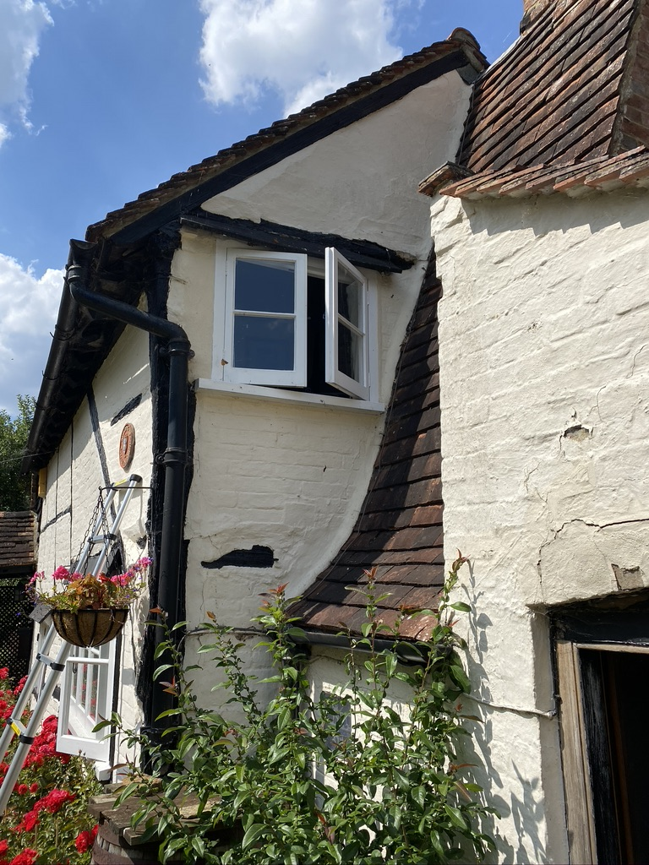
Figure 22, Part of the East Elevation.

Figure 23, East Elevation.
TB. Tiebeam
The tiebeam is severely decayed, approx ½ its depth. This is a particularly critical timber.

Suggested repair scheme
- Remove all mortar along the top and bottom edges.
- Splice in new timber where decay is found.
- Re grout edges with non-hydraulic lime mortar
- Repaired in conjunction with P4’
Estimate See P4’
G1. Girt.
Mostly covered but almost certainly some decay. c. lots of encroaching mortar everywhere.
cracking along the lines of the timbers.

Suggested repair scheme
- Remove all mortar along the top and bottom edges.
- Splice in new timber where decay is found.
- Re grout edges with non-hydraulic lime mortar

Estimated cost £2500 + VAT
PR principal rafter.
It was not possible to examine this timber as it was covered with a cover board or appears to have been replaced.

West Gable.
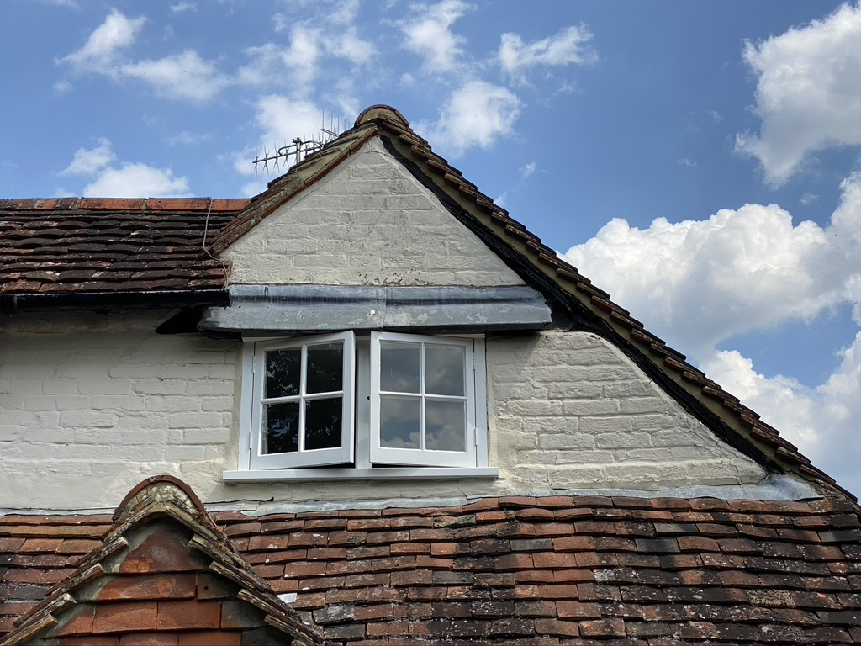
Figure 24, West Gable [above tie beam].
PR1
Principal rafter. This timber would appear to have been with brick.

PR2
Principal rafter. The foot end of this timber has decayed behind the lead flashing.

Suggested repair scheme

- Access
- Remove the lead flashing.
- Remove all mortar along the bottom edges.
- Remove the top tiles near to the affected area.
- Remove tile batten in this area.
- Remove part of the verge to the main roof slope.
- Remove decayed timber.
- Splice in new timber where decay is found.
- Re-instate tile batten.
- Re-instate tiles in both roof slopes.
- Re grout edges with non-hydraulic lime mortar

C1 Collar
The collar is hidden by a lead covered board drip, therefore an assessment was not possible.

TB Tiebeam
This timber was not accessible from the exterior and no concerns were visible internally.

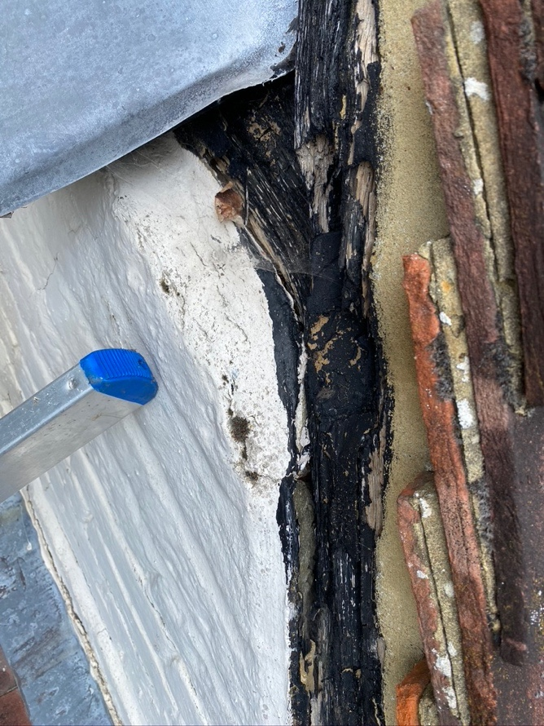  Figure 25, Shows water trapping between the cementitious render and timber. | 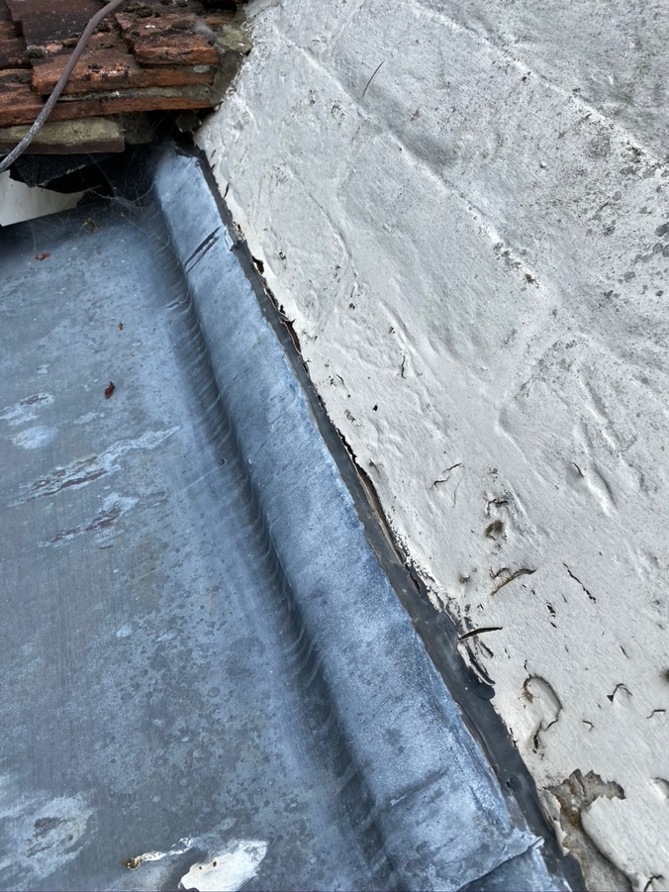  Figure 26, Showing how the lead has not been properly inserted into the bed joint.
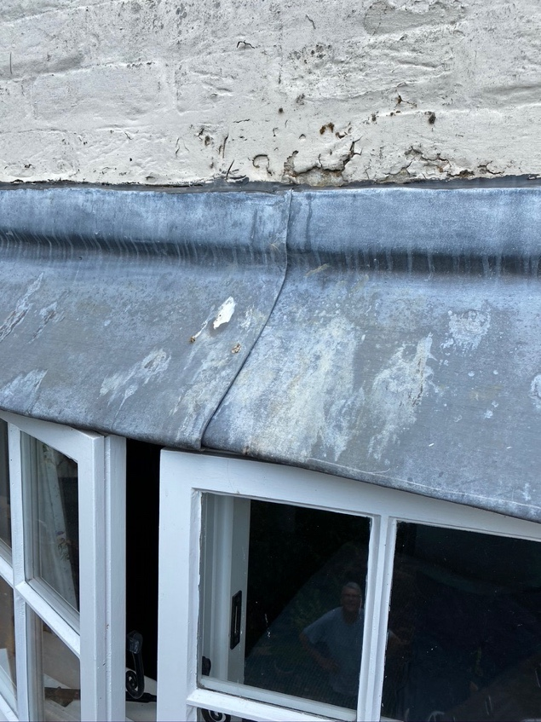  Figure 27, No ‘welt’ on lead. | 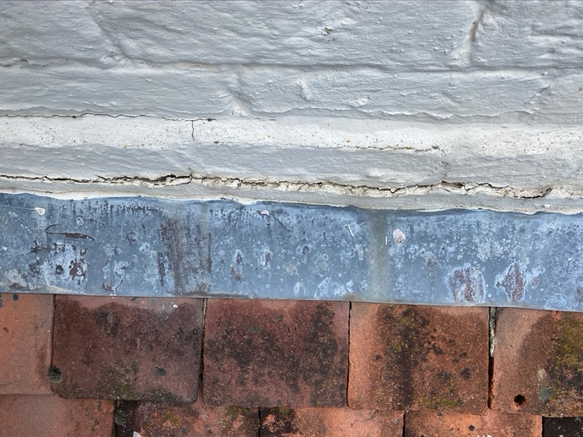  Figure 28, Cracks in the mortar bed joint.

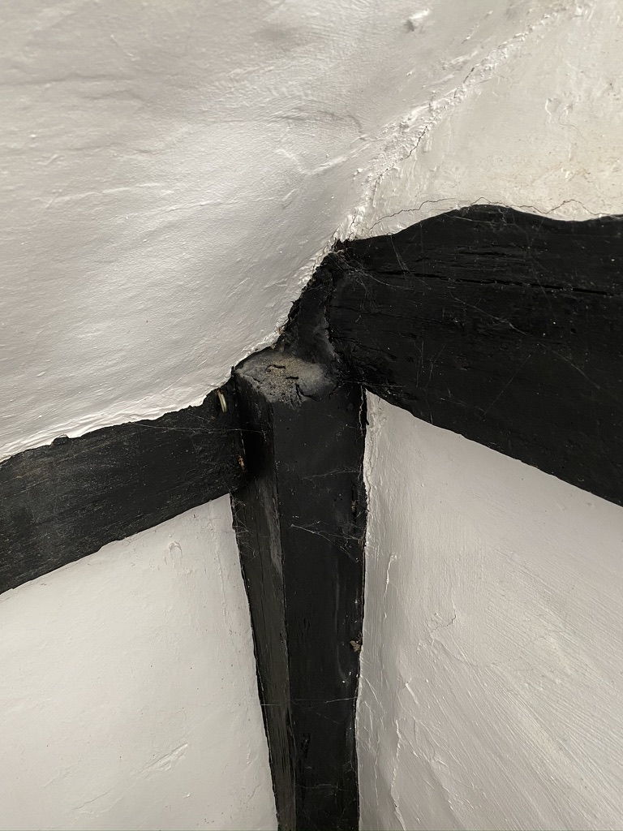
Figure 29, Interior of West Gable,

There are a number of problems around the window in the west gable.
- In places the brick panel infill has moved away from the timber creating a trap for water to gain entry.
- The lead flashing over the window does not have a welt which allows water to travel transversely.
- The lead has not been secured deep enough into the bed joint.
- The lead has not been secured sufficiently into the bed joint and has come away allowing water to penetrate.
- The mortar joint covering the bed joint of the lead flashing for the outshot roof has cracked allowing water ingress.

Estimate £2300 + VAT for all the work to the West gable

East Extension

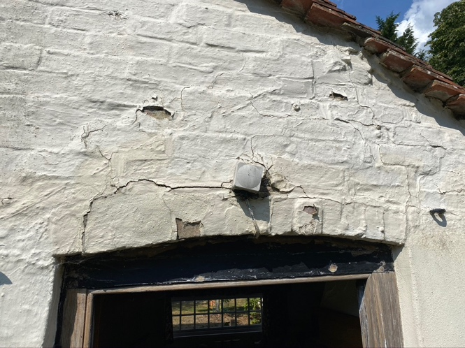  Figure 30, East brick arch | 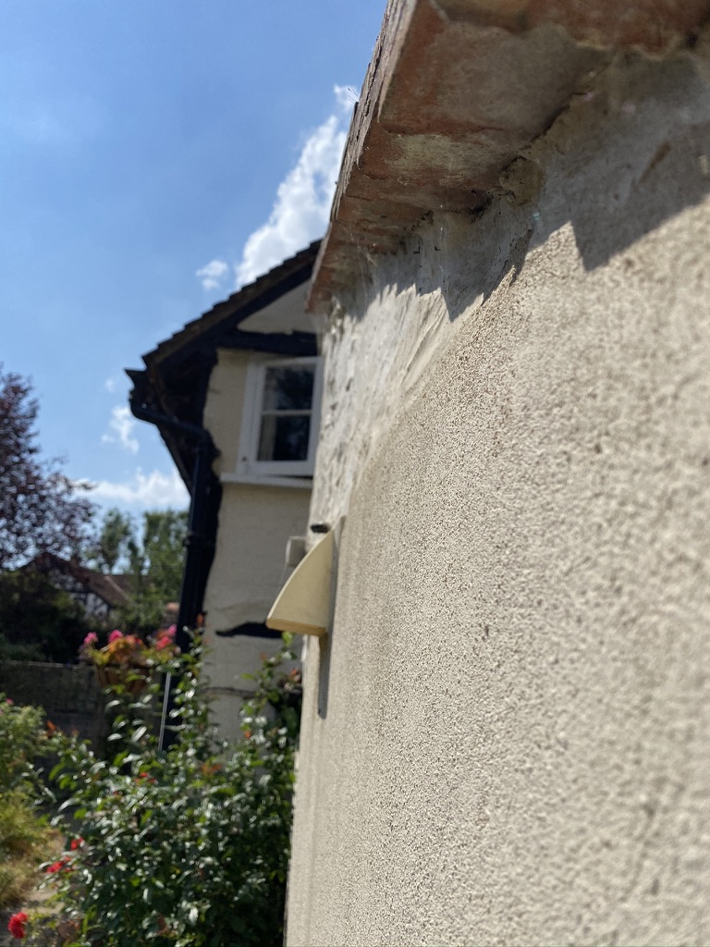  Figure 31, Bulging brickwork above brick arch.

There appears to be both bulging and cracking above the doorway to the Kitchen in the West lean to. There are a couple of problems that I can see but there may be others.
There has clearly been a problem here for some time as the brickwork above the doorway has many mortar repairs and brick face replacements.
The paint covering the bricks is in poor condition with many cracks and pockets in which water can gain entry.

Suggested remedial action
Remove the paint.
Investigate the mortar flashing on the chimney
Investigate the lead flashing at the ridge.
Replace the damaged bricks above the doorway

Re-point the area above the doorway [after paint removal].

Estimate for work to the East extension:
We would not undertake the paint removal.
Everything else = £2240+VAT

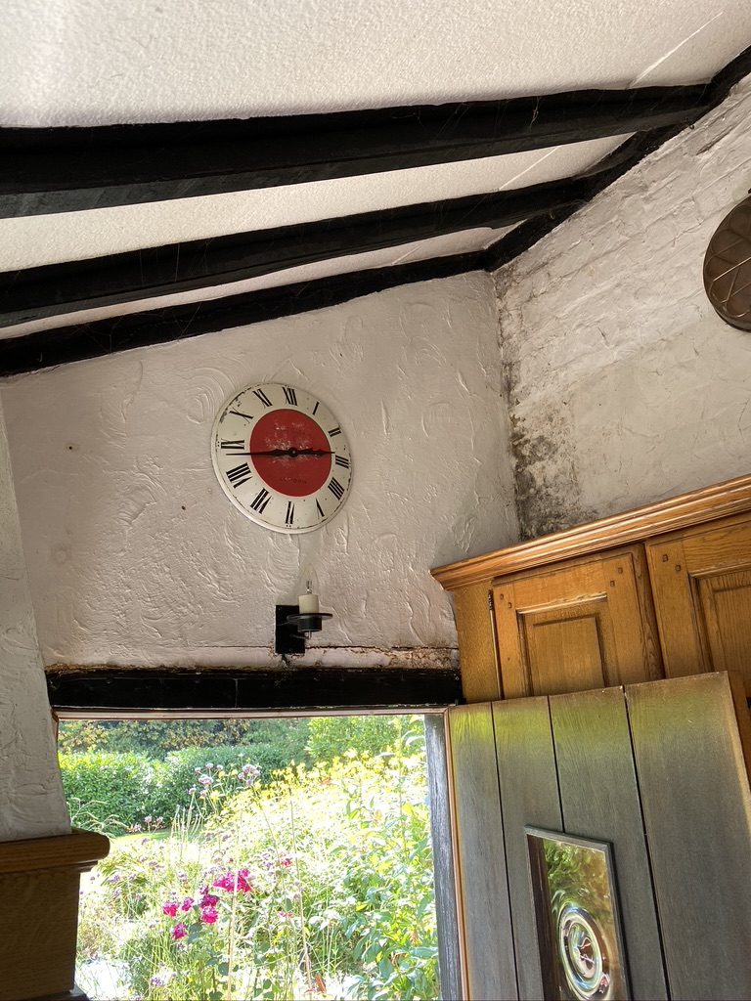
Figure 32, Inside of the brick arch.

General observations
All timbers appear to be covered with black paint and all panel infill has been painted with a minimum of one coat of a modern PVA paint. All impervious paints will allow moisture to gain entry but prevent it from safely evaporating away. This will cause the fabric of the building to take up moisture which in timber will lead to decay organisms and in the brickwork will lead to spalling. Additionally, patches of damp will appear on walls both internally and externally which may present as darker patches or actual fungi or moulds.
This paint should be removed and where necessary re-painted in a breathable paint such as clay paint or lime wash.

Estimate
Estimate No 643
Total estimated above £24,645 + VAT

Joints that have failed or are failing.
- Wallplate/ P4 post connection
- Post 3’ to R5
- R6 New timber under the window both ends [suspect]
- West elevation top of S1

Our general conservation principles
It is important to diagnose the problems that have caused the deterioration of the building through a structural assessment and or condition report. For the most part, problems with historic buildings, and in particular, timber framed buildings, can be traced to decay due to the ingress of water or failure due to ill-judged alterations or interventions. These must be addressed before or at the same time as the repairs are carried out, as unless these are resolved the problem will continue, even after repair.
It is important not only to deal with each individual problem but to take a holistic approach to the building, not only in assessing the problems, but also when considering the remedies, for example; a timber member in need of repair, may be repaired using a suitable in-situ method if it is the only repair required, or, it may be dismantled and repaired using a different technique if the whole frame needs repairing.
No attempt should be made to conceal repair work, but it should harmonize with the original fabric.

The type and extent of repair should consider the following factors;
• Only failed materials should be replaced
• The position within the frame
• Structural forces applied to the member or joint
• The flexibility required of the joint or member
• The visibility of the repair in the finished building
• Character of the building
• Longevity of the repair
• Its historic value (age, rarity etc)
• The amount of material being removed
• The effectiveness of the repair, structurally and visually
• Environment of the repair
• Use of the building i.e. restored to original use or upgraded to new use

All replacement materials should be suitable for their intended use, but match the original for type, size, colour, texture, style and method of fixing.

All materials and proposals should be approved by the Local Authority Conservation Officer before any work starts

Dismantling
Dismantling should be considered the “last resort” and should be kept to a minimum, as dismantling usually brings about the ppotential for further damage to the existing historic fabric, both of the frame, panels and other materials.

Workmanship
All work shall be reproduced to match the quality, size, type, style and material of the original, in all respects.

Timber

Decay and infestation of timber
Timbers showing signs of fungal decay and infestation of insects should be assessed for it's reduced structural performance. Unless timbers are identified as failing, they should be retained. Generally, timbers removed from the source of moisture and dried will not continue to degrade.

Replacement materials specification
Every effort should be made to retain all material contained in the fabric of the historic building, but where timber has to be replaced either completely or in part, the replacement timber should be new and of the same:

• Species
• Dimensions
• Square-ness
• Grade (quality)
• Grain, (on braces etc it should follow the same pattern as the original as they often
follow the curvature of the timber.
• Conversion type
• Moisture content
• Speed of timber growth
• Shape, this should include softening the edge of spliced in timber to reduce the
visual abruptness of a new piece
• Wane, its shape and position on the piece.

As a general principle, completed repairs need to fulfill their structural function, but also retain the maximum amount of historic fabric, whether the repair uses timber, steel, resin or other strengthening material, its impact will need to be minimised and discreet. Where modern re-enforcing materials have to be used, (for example; where a timber repair may mean the loss of more than acceptable amount of historic fabric or where a repair will not be seen and an economic judgement has to be made) they should be simple, discreet and effective in their design, using non corrosive materials. Bolts, nails and other fixings should be similarly hidden beneath plugs and facings etc.

Where possible, timber repairs should be repaired with timber, (following guidance from the Replacement timber specification above).

Brick

New work
Where brick work has to be dismantled and re-done. Any existing brick work should be carefully recorded before dismantling and setting aside for re-use. Where panel infill is concerned this should be on a panel by panel basis so that the same bricks can be re-used in the same panels.
New reclaimed bricks should be procured and matched for size, colour, texture and hardness.
The new mortar should be matched to the original in type, colour and texture However, it be noted that new work will look different as old work will have aged being coloured by dirt and micro plant growth.

Repairs
Only spalled, broken or missing bricks should be replaced. Where possible defaced bricks can be turned around (so long as only one side is required to be visible). Where bricks cannot be turned around, new bricks should be procured that match for size, colour and texture.

Re-pointing
The constituents and proportions of the mortar used to bed the bricks should be carefully analysed, matched and approved before work can commence. I would recommend a sample patch is prepared so that we can clarify final details of the specification, demonstrate the standards of workmanship and finish, and provide a control sample for guidance of the rest of the work.
Following conservation principles there should be a policy of minimum intervention (maximum retention) of historic material and we would recommend the replacement of mortar only where;
- Original lime mortar has failed.
- Original lime mortar has been replaced with cementitious mortars.
- Alterations have taken place and incorporated cementitious mortars.
- Bricks are broken or deep holes drilled.
- Where pipes or cables exit/enter the bricks surface.
The removal of mortar should be carried out using hand tools and not electric grinders which can easily damage bricks even in experienced hands and when great care is exerted.
Cementitious mortars can be very hard and difficult to remove but where cementitious mortar does exist in this building, we would only recommend its removal if this can be done without damaging the surrounding bricks.

Notes to consider concerning repairs
- Even with extreme care there will be disturbance to the internal plaster work adjacent to the works being carried out which we may not be aware of at the time of occurrence. This will be made good before completion.
- Lime patch repairs should be Non-Hydraulic class 1 or feeble lime putty mixed with coarse aggregate and hair and where these repairs are required within timber, this can be coloured with earth pigments to harmonise with the timber.
- Where lime repairs are required in panel infill, they should be painted with lime wash or similar breathable paint.
- Timber repairs that incorporate steel screws will hidden with a timber plug of the same species.
- We do not advise the colouring of new timbers to match old. But allow the timber to mellow with age to blend with the existing.
- New oak is likely to “leech” tannins, which present as a brown watery stain. This will occur for some months, depending upon the amount of water the timber receives and the amount of tannin in the timber. It is advisable to wait for the tannins to go before painting any panel infill or the staining could be very visible.
- Delicate or valuable furnishings or artworks should be removed from the immediate area including on the insides wall where work is being carried out.
- We advise you to check with your household insurance company to check if the work being carried out effect your policy.
- The Panels will need to dry before they can be decorated, and the drying time will depend on many things including the thickness of the daub and the weather conditions.
- Please do not engage our services unless you have the means in place to pay.
- We will expect a deposit before we start, interim payments and the balance within 7 days of completion.

We have not carried out a condition survey of the building as a whole. This report comments on the area of your concerns raised during our visit. A full condition can be carried out which would provide you with the necessary information required to understand the full condition of the building.

I hope this estimate meets with your approval, if there are any questions please do not hesitate to get in touch.

Yours Faithfully

Roland Locke MSc

Appendices

Appendix A

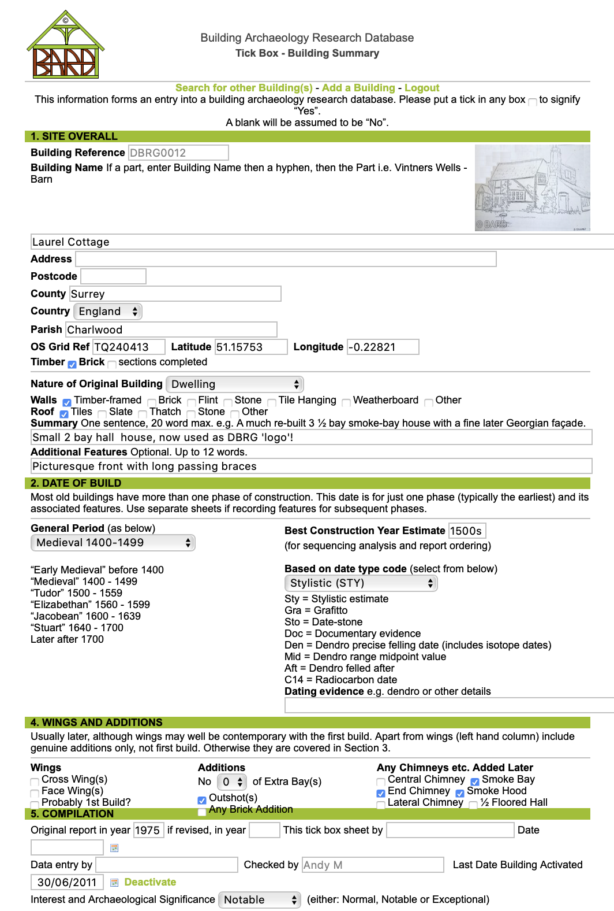
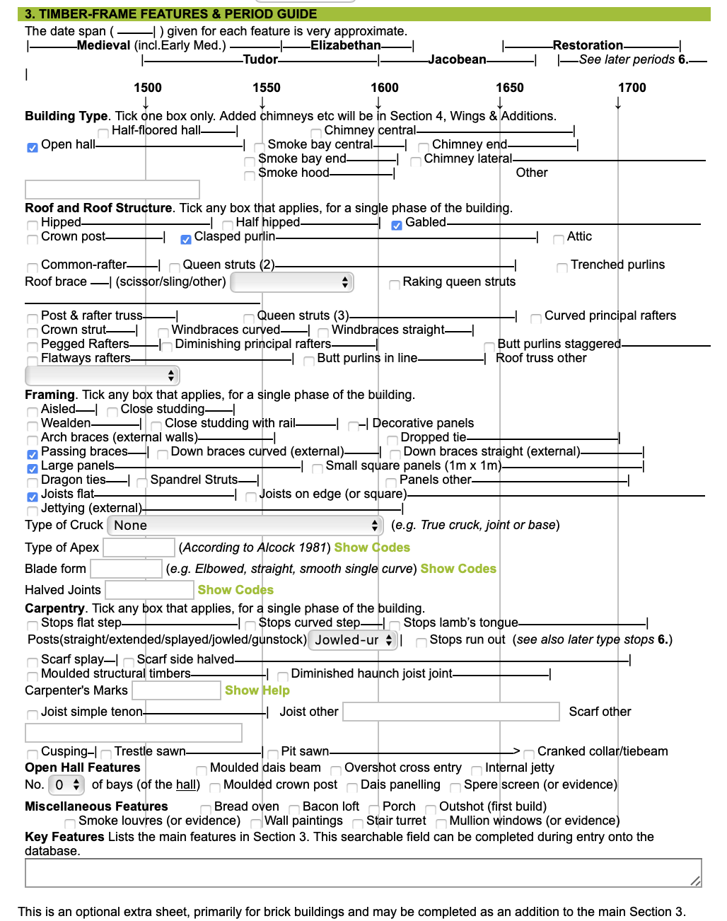
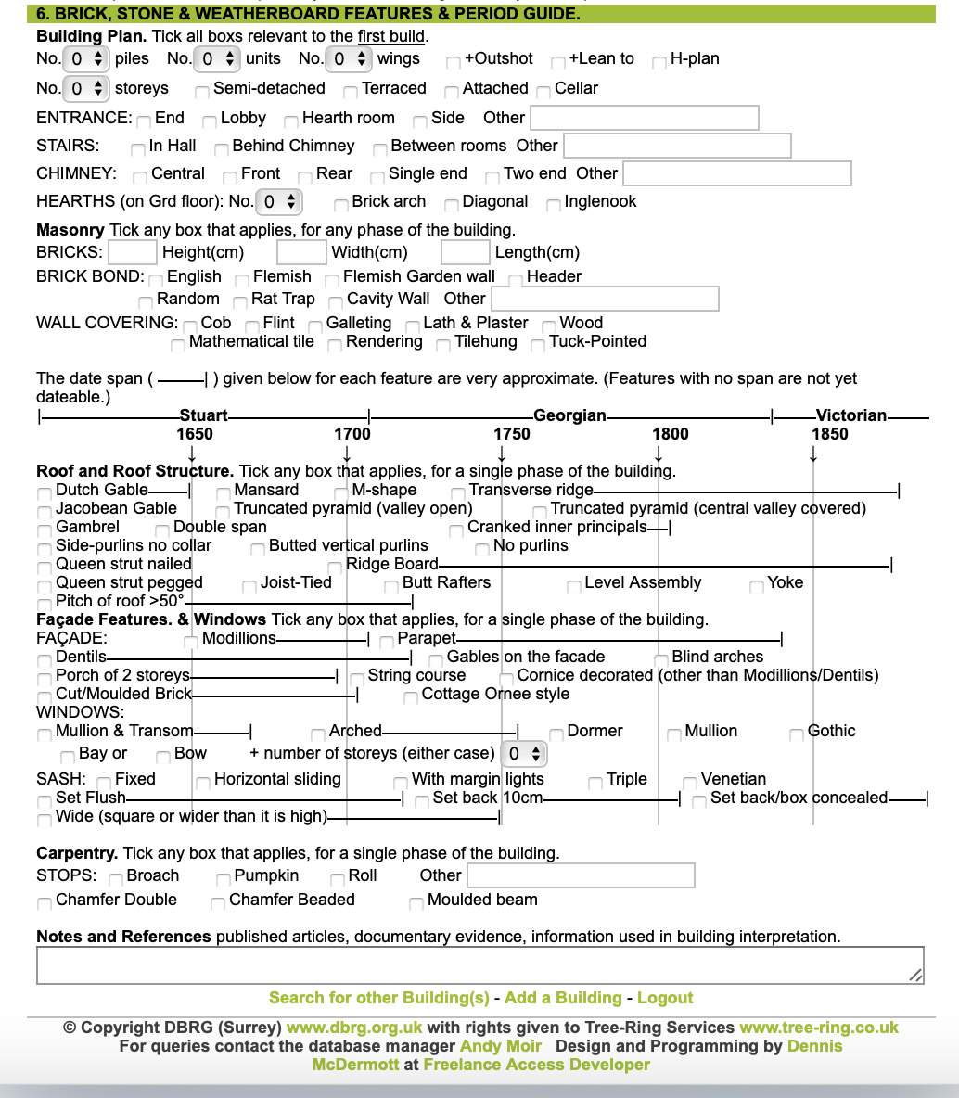

Figure 34, Data sheet from BARD website.

Historic Building Conservation and Repair Ltd, Director: Roland Locke MSc, Correspondence address: Steepwood Bungalow, Adversane Lane, Billingshurst RH14 9EG: Registered company No 8860281 : VAT No 201435168 : Web site: www.hbcandr.com

